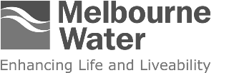

Melbourne Water

Price Submission 2021
  - 1 July 2021 to 30 June 2026

Aboriginal Acknowledgement
Melbourne Water respectfully acknowledges Aboriginal and Torres Strait Islander peoples as the Traditional Owners and custodians of the land and water on which all Australians rely. We pay our respects to Wurundjeri Woi wurrung, Bunurong and Wadawurrung, their Elders past, present and future, as Traditional Owners and the custodians of the land and water on which we rely and operate.
We acknowledge and respect the continued cultural, social, economic and spiritual connections of all Aboriginal Victorians. We also acknowledge the broader Aboriginal and Torres Strait Islander community and their connections with lands and waters, and recognise and value their inherent responsibility to care for and protect them for thousands of generations.
Melbourne Water acknowledges Aboriginal Victorians as Traditional Owners and, in the spirit of reconciliation, we remain committed to developing partnerships with Traditional Owners to ensure meaningful, ongoing contributions to the future of land and water management.
9 November 2020
Ms Kate Symons
Essential Services Commission
Level 37
2 Lonsdale Street
Melbourne Victoria 3000
Dear Ms Symons,
On behalf of the Board of Directors we are pleased to present Melbourne Water’s Price Submission 2021. This submission represents our best offer, and is the result of a focused, disciplined and whole-of-organisation effort to deliver value for our customers.
Our household, business and retail water company customers, and Waterways and Drainage Customer Council, have been integral to the development of the proposals contained within this submission and we thank them for their considerable investment of time and expertise.
We will deliver the outcomes our customers value
Our submission is built around the six outcomes our customers told us they value.
- Access to safe and reliable water and sewerage services – a stand-out priority for our customers, we will maintain our current high-quality services while delivering for new Melburnians, including planning collaboratively for future supply augmentations.
- Melbourne’s environment, rivers, creeks and bays are protected and Melbourne Water’s greenhouse gas emissions are minimised – we will continue to protect Melbourne’s environment, and play our part in addressing climate change.
- Melbourne remains liveable as it deals with the impacts of climate change and population growth – we will increase community access to Melbourne Water land and continue to reduce flood risks.
- Melburnians are empowered to support the design and delivery of service outcomes – we will empower others to deliver more, particularly for our waterways, than we could on our own.
- Easy, respectful, responsive and transparent customer service – we will reach new standards in customer service for each of our major services.
- Bills kept as low as possible – we have kept our bills as low as possible through the application of strong internal discipline and robust Board oversight.
We will be more accountable than ever
We commit to our customers that we will retain the outward focus we applied during our engagement journey throughout the regulatory period via:
- a renewed emphasis on transparency in the form of annual performance reporting directly to a representative customer forum (we will also publish results on our website)
- the introduction, for the first time by Melbourne Water, of guaranteed service levels to emphasise our commitment to delivering on our promises to our customers.
We have applied strong internal discipline and listened to our customers
We have taken action to keep our bills as low as possible and deliver greater customer value (values shown are five-year revenue requirement aggregates) by:
- increasing our capitalisation of Victorian Desalination Plant security payments – a $217 million reduction
- accepting more risk on behalf of customers in the management of our capital program and deferring $498 million in capital projects – an $85.8 million reduction
- smoothing our capital program to accept some delivery risk associated with the peak in years one and two – a $42.9 million reduction
- keeping our base opex flat while supporting a growing population – based on forecast population growth of 1.95 per cent per annum, this represents a 2 per cent per annum efficiency outcome
- accepting our customers’ strong desire for an uplift in waterways and drainage service levels via additional investment in high value-add services – a $43.8 million addition.
We remain focused on affordability
- In annual average dollar-per-customer terms (households and businesses) our bulk water and sewerage charges will drop for City West Water (2.12 per cent), South East Water (1.43 per cent) and Yarra Valley Water (1.24 per cent). Combined these three retail water companies account for 98.7 per cent of our revenue requirement.
- Regionally, our bulk water charges (in dollar-per-customer terms) will decline in annual average terms for Barwon Water (0.79 per cent), Westernport Water (0.64 per cent) and Gippsland Water (3.41 per cent), while for Western Water and South Gippsland Water the average dollar-per-customer will rise 0.14 per cent and 1.50 per cent respectively.
- We will deliver the service uplift our waterways and drainage customers told us they wanted, and were willing to pay for, and keep price rises to a minimum. Residential, non-residential and rural charges will increase 1 per cent per annum across the period from bases of $104.32, $156.72 and $57.28 per annum respectively.
Delivering will be challenging but we are up to the task
The COVID-19 pandemic, population growth (past and expected) and climate change are key challenges that we must and will address across the regulatory period. Our responses to each are considered, proportionate and designed to deliver the outcomes our customers value at a price that fairly balances the service delivery risks.
We are proud of the way we have gone about the task of preparing this submission and are confident it demonstrates our commitment to diligently, carefully, openly and honestly serving the needs of the people who benefit from our services.
Yours sincerely,

Michael Wandmaker
Managing Director
John Thwaites
Chair, on behalf of Board

Board attestation statement
The directors of Melbourne Water, having made such reasonable inquiries of management as we considered necessary, attest that, to the best of our knowledge and for the purpose of proposing prices for the Essential Services Commission’s 2021 Melbourne Water Price Review:
- information and documentation provided in the Price Submission and relied upon to support Melbourne Water’s Price Submission is reasonably based, complete and accurate in all material respects
- financial and demand forecasts are Melbourne Water’s best estimates, and supporting information is available to justify the assumptions and methodologies used
- the Price Submission satisfies the requirements of the 2021 Melbourne Water Price Review Guidance paper issued by the Essential Services Commission in all material respects.

Michael Wandmaker
Managing Director
John Thwaites
Chair, on behalf of Board

The directors of Melbourne Water note that the COVID-19 pandemic represents an atypical level of uncertainty for a price submission.
Responding to the COVID-19 pandemic, and aligned with the Essential Services Commission’s revised guidance note, Melbourne Water has undertaken additional engagement and analysis to ensure that the submission remains founded on suitable “best estimates” of financial and demand forecasts, noting the high degree of uncertainty surrounding COVID-19. Importantly we have taken “best estimates” to mean estimates that are founded on robust and reasonable point-in-time information and analysis and that do not seek to push COVID-19 risks onto our customers.
Contents
1. A submission with a difference 8
2. Melbourne’s challenges are our challenges 9
2.1 The COVID-19 challenge 9
2.2 Key themes – population, climate and assets 14
3. Delivering our customer ambition 16
3.1 Early, deeply, broadly – our engagement story 16
3.2 Outcomes our customers value 20
3.3 Other customer-centric commitments 27
3.4 Robust and collaborative demand forecasts 30
3.5 Focused and disciplined governance 31
3.6 Keeping bills as low as possible 41
4. PREMO assessment 53
PREMO – Risk 53
PREMO – Engagement 54
PREMO – Management 55
PREMO – Outcomes 56
Attachment 1: COVID-19 considerations 57
Additional engagement activities 57

How to read this document
This is a price submission document prepared solely for the purposes of meeting our obligations as a regulated water business, including the Essential Services Commission’s Melbourne Water’s 2021 water price review: Guidance paper (the Guidance Paper).
We have prepared our submission in two interrelated parts. The first part, our Price Submission, represents a concise, stand-alone description of our proposals and commitments across the regulatory period. It sets out the context within which we prepared this submission and how we have addressed the COVID-19 pandemic. It also describes our engagement approach, customer outcomes and commitments, demand forecasts, how our Board and Leadership team have approached the management of risk and investment, and our prices. It also contains our self-assessment under the PREMO (performance, risk, engagement, management and outcomes) model.
The Price Submission should be read in conjunction with the Price Submission Supplement – the second part of our submission. The Price Submission Supplement contains a more detailed account of each element of our regulatory proposal and has been written to directly address the requirements of the Guidance Paper.
All values presented in the Price Submission and Price Submission Supplement are in $real 2020-21 unless otherwise stated.
Other key references
While the Price Submission Supplement provides a detailed account of our proposal against Guidance Paper requirements, in many instances we have prepared supporting documents to provide comprehensive accounts of specific aspects of our proposal and its development. These documents support the Price Submission, are referenced throughout and are available to the Commission on request. Key documents include the Price Submission 2021 Engagement Supplement, Demand Supplement, Risk Strategy and Waterways and Drainage Investment Plan.
Relationship to the Waterways and Drainage Investment Plan
This submission is a companion document to the Waterways and Drainage Investment Plan (WDIP), which sets out Melbourne Water’s responsibilities, goals, levels of service and programs of work for waterway management, flood management and drainage. The preparation of a Waterways and Drainage Investment Plan is a key requirement of Melbourne Water’s Statement of Obligations, which are issued in accordance with the Water Industry Act 1994. The Waterways and Drainage Investment Plan defines the things we will do, and what it will cost, to deliver on our responsibilities and proposed levels of service for the period 2021-22 to 2025-26.

A submission with a difference
This is a price submission with a difference. It is different in a number of ways that are central to the story of our Price Submission 2021 (PS21) – and not just because it was prepared during a declared pandemic.
It is different because it will be our first experience with the new PREMO framework. It is also different in the ambition we have set for ourselves and the submission. It’s different because of the rigour we have imposed on ourselves to ensure customers are not paying for costs we can avoid or risks we can manage. It’s different because we have gone to significant lengths to understand the outcomes our customers care about most and ensure we deliver these outcomes. We will be reporting back to them to prove our commitment to meeting their expectations.
Pricing submissions are a part of the rhythm of life for a regulated water utility. Whether the intervening regulatory period is three years, five years or something else there is a degree of familiarity with the drive to outline plans and prices for the coming period. Our customers remain the households, businesses and retail water companies who enjoy the same (albeit continually evolving) high-quality water, sewerage, and waterways and drainage services we have always provided. Our regulatory task continues to be to plan and act prudently and efficiently as we deliver the services and outcomes our customers value.
We have always been driven by the needs of our unique and diverse customer base. We have not always been good at sharing this part of our story. Conscious of this, over the past five years we have driven ourselves to become a more customer-centric organisation, prioritising genuine two-way dialogue, and embedding engagement and customer insights into how we do business.
Our 2018-2023 Customer and Community Strategy formalises our recommitment to continuous improvement and a customer-centric way of doing business. It does this via a number of key implementation priorities:
- Customer centricity: seeking and understanding our customers’ perspectives to strengthen relationships, enhance customer experience and improve service outcomes.
- Our community: engaging our diverse customer base on decisions that involve and impact them, while lifting awareness of our role and services.
- Our services: continually evolving and improving our services in a way that delivers the outcomes our customers value.
- Customer and community capability: empowering all levels of our organisation to deliver improved services, relationships and experiences to customers and community.
- Disciplined delivery: applying strong governance and oversight, leading to better customer and community outcomes.
Our ambition then, through this submission, is to not only ensure we continue to deliver highly valued essential services to Melburnians and our customers in the wider Port Phillip and Westernport regions, but to do this in a more transparent and accessible way that places the customer at the heart of the process.
We are confident our submission achieves this and have self-assessed as “advanced” under the PREMO framework, reflecting the significant value this submission represents for our customers.

Melbourne’s challenges are our challenges
Melbourne Water plays a unique role in the life of Melburnians and those living in the Port Phillip and Westernport regions. Part essential service provider and part steward of key aspects of the liveability of our region, we provide bulk water and sewerage services, oversee the way that drainage is managed to reduce the impacts of flooding on people and the environment, care for our waterways, creeks and the natural ecosystems which rely on them, and help to create outstanding community spaces.
This role requires us to tackle a number of fundamental challenges facing the region, including catering for an ever-growing population, acting to address climate change and, in 2020, managing the risks associated with the COVID-19 pandemic.
This submission was already being developed as the COVID-19 pandemic emerged in early 2020. The pandemic represents significant uncertainty as governments and the community deal with ongoing restrictions and the corresponding impact on businesses and the economy. The immediate challenges of the COVID-19 pandemic are discussed in Section 2.1; however, the submission also sets out the way in which we propose to tackle the big long-term challenges (Section 2.2) that will still be there when the pandemic passes.

The COVID-19 challenge
The following summary outlines how we have sought to deal with the uncertainties and challenges that the pandemic poses to our forecasts and this submission. To do this it touches on some of the key commitments that are fully introduced later in the submission. We have carefully considered the implications of COVID-19 on our submission and acted to ensure our customers are not paying for any additional uncertainty caused by the pandemic.
Based on a review of available commentary and an international border which is closed to foreign citizens, it is likely that COVID-19 presents some level of downside risk to our demand forecasts, which are underpinned by forecast growth in net overseas migration.
In early September 2020 Australia’s borders were closed, with only Australian citizens, residents and immediate family members able to travel or enter the country without obtaining an individual exemption.
It is uncertain, however, exactly what level of impact this will have (lower foreign citizen migration may be offset to some degree by repatriation of Australian residents in the near term) and over what period (when current border restrictions will be lifted is unknown as is the impact of any change on net overseas migration).
We have carefully considered the pandemic and the impact it may have on future demand and customer preferences (particularly where this impacts near-term affordability) in order to consider the possible implications for our demand and expenditure forecasts, as well as our revenue and prices.
To do this we considered two key questions:
- What additional steps can we take to make sure we are delivering fair prices for our customers across the regulatory period, noting the current constrained economic context? We define “fair” in this context as prices that minimise one-off year-to-year changes and that reflect underlying expenditure.
- How is COVID-19 affecting the growth outlook and what are the possible implications for our submission of a revised growth outlook?
We have carefully considered these questions in relation to our expenditure and prices, noting their heavily interrelated nature.

Additional engagement and ongoing monitoring
For question one we added an additional stage to our engagement program. Noting that the closing stages of our engagement program ran concurrently with the emergence of the COVID-19 pandemic and the first stage of social restrictions, this stage sought to test and refine draft proposals on how we might:
- ease bill impacts in the community (for example, delay price and service increases for Koo Wee Rup Longwarry–Flood Protection District direct service customers)
- monitor and respond to the impacts of COVID-19 across the regulatory period (for example exploring a framework and mechanism via which Melbourne Water might provide proportionate financial relief depending on the nature of the emerging issue)
In September 2020 a deliberative forum (using the same panel engaged to consider our final customer outcomes) considered key questions relating to affordability and appropriate measures we might take to ensure our prices remain fair across the regulatory period. The panel was highly supportive of our proposed approaches to the management of the waterways and drainage charge, and longer-term COVID-19 monitoring and response across the regulatory period. These additional measures are outlined in the “proposed response” section below.
Our COVID-19 engagement activities are detailed in Attachment 1.
We also supplemented our engagement program with a scan of a range of data sources to understand how COVID-19 is impacting customer affordability.
- From April 2020, we have included a series of COVID-19 tracking questions to our community perceptions survey to add to our knowledge of customer impacts. On a fortnightly basis we are surveying a representative sample of the community with a series of questions focussed on perceptions and confidence in ability to pay water bills.
- Retail water company insights into end-use customer financial stress and take up of hardship programs and other COVID-19-related support packages.
- Ongoing industry research and data collection on community financial stress and ability to pay for utilities (for example Water Services Association of Australia (WSAA) and Essential Services Commission (ESC) data collection).
This scan tells us there has been an increase in households and businesses who are struggling to pay essential bills.
This monitoring work is ongoing and provides insight into the current and evolving community sentiment about the impacts of COVID-19 and perceptions of ability to pay bills as the pandemic progresses. These insights reinforce the emphasis our price submission places on balancing affordability considerations with service levels and quality, and the importance of our affordability-related customer outcome: ‘Bills kept as low as possible’ (see Section 3.2).

Growth outlook and its implications
For question two, we focused on what a COVID-19-adjusted demand profile might look like and then considered its implications for our capex and opex forecasts.

COVID-19-adjusted growth outlook
Our original demand forecasts for the regulatory period are ultimately founded upon Victoria in Future 2019 (VIF2019), Population and Household Projections (July 2019) data series forecasts, which were released prior to the emergence of the pandemic. We engaged property advisory and market research consultancy Macroplan to provide an independent, expert opinion on how Victoria in Future 2019 population level forecasts might be adjusted to take into account known or likely impacts of COVID-19. In summary, compared with the Victoria in Future 2019 projections, its findings (detailed in Attachment 1) suggest:
- an expected drop in growth for the 2020-21 year – with some 86,000 less people residing in the greater Melbourne region than forecast by Victoria in Future 2019
- a rapid return to prior growth paths from 2021-22
- a 2021-22 to 2025-26 forecast growth rate of 1.93 per cent that is largely aligned with the Victoria in Future 2019 growth rate (1.95 per cent) for the same period.

Implications of a COVID-19-adjusted growth outlook
Our revenue requirement and prices are founded on our estimates of prudent and efficient opex and capex, which are in turn influenced by the size of our asset base, recent growth and growth forecast to occur across the regulatory period. The difference in the growth rate (0.02 per cent) has a $1 million effect on meeting the 2 per cent efficiency calculation over five years.
Having finalised our original demand forecasts during the first half of 2020 – when the COVID-19 pandemic was in its early stages – we considered two management responses to Macroplan’s COVID-19-adjusted forecasts for the purposes of this submission:
Scenario 1: Assumes the acceptance of the COVID-19-adjusted demands (and expenditures) as our “revised best estimates”. Under this scenario demand forecasts are adjusted for COVID-19, with actual demand in line with adjusted forecasts.
Scenario 2: Assumes the retention of pre-COVID-19 demands (and expenditures) – our “original best estimates”. Under this scenario demand forecasts are unadjusted for COVID-19, with actual demand (that is post submission) lower than submission forecasts and in line with the Macroplan forecasts.
The implications of COVID-19-adjusted demand forecasts on our expenditure forecasts are considered in Attachment 1, along with key modelling outputs and assumptions used to draw the following insights.
Modelling of the two scenarios outlined above shows that:
- revised demand forecasts have a negligible impact on our proposed expenditure
  - all capital projects with a growth driver have been proposed on a “just-in-time” basis to deal with recent growth that has occurred during Price Submission 2016 (PS16)
  - chemicals and energy costs would be $1.3 million lower under the modelled COVID-19-adjusted growth outlook
- revised demand forecasts have a negligible impact on our overall revenue requirement
  - the waterways and drainage revenue requirement is unchanged across the two scenarios
  - the water and sewerage revenue requirement would be $1.3 million lower (in aggregate across Price Submission 2021) under Scenario 1 – on a revenue requirement aggregate of $6,731.6 million
- prices would be higher under Scenario 1 than Scenario 2
  - on average across the period:
  - waterways and drainage charge prices would be $1.30 higher for residential, $1.90 higher for non-residential (on minimum) and $0.70 higher for rural customers
  - water variable tariff prices would be $264.40 per megalitre under Scenario 1, compared to $263.10 per megalitre under Scenario 2
  - sewerage fixed tariff prices would be $440.4 million per annum under Scenario 1, compared to $440.3 million under Scenario 2
- the risk profiles of the two scenarios are different, with Scenario 2 representing a $16.6 million revenue (net of avoided opex) risk to Melbourne Water, compared to Scenario 1 where the risk is effectively re-balanced via higher customer prices
- the reduction in the growth rate from 1.95 to 1.93 per cent represents about $1 million variance to the 2 per cent efficiency target over the five-year regulatory period.
This analysis demonstrates that, on balance under Scenario 2 the risk lies with Melbourne Water, not our customers. The revenue risk is greater than the cost risk.

Proposed response to COVID-19
Our response to the COVID-19 pandemic seeks to balance the uncertain nature of its impact in the short, medium and long term, with the longer-term nature of the outcomes and services our customers have told us they value. In light of the challenges posed by the pandemic, we have amended our submission to ensure our customers are not bearing an unfair burden from the risks they expect us to manage.

Shouldering greater risk on behalf of customers
- We are mitigating any capital delivery risk by “smoothing” the profile of our capital program – effectively taking the years one to three expenditure peaks and pushing these into the final year of our program. This reduces the amount customers will pay for our capital program by $42.9 million over the regulatory period.
- We have elected to base our submission on our “original best estimates” of forecast demand and expenditures (Scenario 2 above), bearing the revenue risk should actual (post-submission) demand be lower than our forecasts.
  - This decision enables us to keep prices lower than they otherwise would be under the “revised best estimate” scenario modelled above.
  - It is in line with customer feedback, particularly from the retail water companies, who were strongly of the view that we should seek to minimise any upward price pressures arising from COVID-19. Our customers expect us to accept higher revenue risk, rather than pass that risk on to them via revised forecasts and higher prices.
- We offer to review the forecasts between the Essential Services Commission’s draft decision and final decision to take account of a better understanding of COVID-19 impacts.
Prices
- We are replacing what was a proposed one-off, year one (2021-22) price increase for our waterways and drainage charge with a gradual increase across the five-year regulatory period.
  - This applies to our residential, non-residential (minimum fee) and rural charges. For example, this means that the annual residential charges in 2021-22 will be $105.36 rather than $107.47 we were originally considering (up from a base of $104.32).
  - We recognise this change is modest, but we also know that at times like this every dollar counts for many of our customers.

Ongoing monitoring and customer engagement
- We will continue to monitor the emerging situation, including via engagement with the retail water companies and monitoring related industry research to understand how COVID-19 impacts customer affordability as the economic effects of the pandemic evolve. This will include continuing to survey household and business customers at regular intervals (currently fortnightly), with a series of questions focused on service affordability, to aid our understanding of the social, health and financial pressures arising from the pandemic.
- We will use the insights we gather to actively monitor the case for setting our prices to a fair level (lower than the regulatory price cap) in any given year. In our engagement with the deliberative panel we outlined options such as temporary pauses in scheduled price rises (waterways and drainage charge), multi-year adjustments of price paths and/or a revisiting of customer-derived levels of service, as possible responses to ensure our prices remain as “fair” as possible across the period.
- We will do this by adding a COVID-19 discovery, reporting and response element to the customer forum(s) we will establish under our performance management framework (Section 3.3).
  - Discovery – Coinciding with their establishment we will work collaboratively with the customer forum(s) to develop specific reporting metrics and response structures, including clear “trigger” levels to guide appropriate responses by Melbourne Water. This element would be concluded within the first six months of the regulatory period.
  - Reporting – Each meeting of the customer forum(s) would include a clear update on:
    - general community affordability metrics (using both Melbourne Water captured insights and available public information) relevant to customer hardship, unemployment levels and related measures
    - our delivery against our investment plans – we will expand the reporting against the outputs associated with the “Bills kept as low as possible” outcome (Section 3.3) to include meaningful references as to how we are tracking against our aggregate (5-year) expenditure plans.
  - Response – Where our reporting shows we are approaching or exceeding pre-agreed “trigger levels” Melbourne Water would outline its proposed response and how this aligns with the suite of possible responses identified in the discovery phase.
    - The overarching objective of any proposed response will be to ensure that customers continue to pay a “fair” price for their services across the period.
- As a last resort we will engage the Essential Services Commission about its unforeseen events mechanism.

Key themes – population, climate and assets
Over the past three years we have worked with the community and Melbourne’s retail water companies to deliver (and refresh) landmark strategies that identify the challenges Melbourne’s water, sewerage, and waterways and drainage services face today and into the future. Recent growth has been an important driver of expenditure and will remain so once COVID-19 passes.
We have drawn on these strategies, our day-to-day operational experience and our engagement with customers to identify the key challenges we are addressing as part of Price Submission 2021.
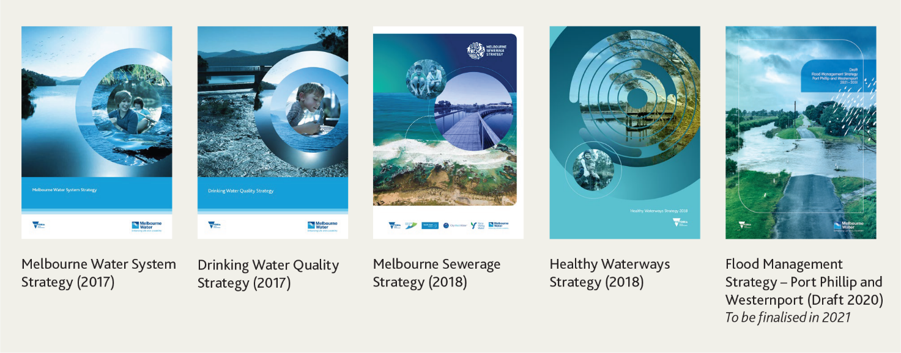

A growing population
- Population growth places pressure on water supply, and sewage transfer and treatment capacity, and increases the number of people who want to access waterways for recreation and to receive the health benefits of being in nature. It tends to bring more hard surfaces such as roads, roofs and pavements, which increase stormwater runoff, impacting waterway health and the risk of flooding. Population growth also contributes to a reduction in the extent of native vegetation cover and biodiversity along waterways and in catchments.
- Despite the effects of the pandemic, Melbourne will still have half a million more residents in 2021 than in 2016 (Table 1). Another half a million more are expected to be living in Melbourne by the end of the Price Submission 2021 period.
- A disproportionate amount of this growth has (and is expected to) occur within the catchment of our WTP, creating a special challenge for this vital piece of treatment infrastructure.
Table 1 – VIFSA (refer note 1) (July 2019) – population growth projection
Population forecast | 2016 | 2021 | 2026 | Compound Annual Growth Rate
Melbourne | 4,683,972 | 5,270,871 | 5,803,337 | 2.39% from 2016 to 2021  1.94% from 2021 to 2026
Western Treatment Plant (WTP) catchment | 2,302,383 | 2,616,022 | 2,882,274 | 2.59% from 2016 to 2021  1.96% from 2021 to 2026
Eastern Treatment Plant (ETP) catchment | 1,706,229 | 1,826,989 | 1,951,942 | 1.38% from 2016 to 2021  1.33% from 2021 to 2026
Note 1: VIFSA refers to the Victoria In Future Small Area (2019) projections. Note also that these projections were developed for sewage forecasting purposes and use small areas specific to the three metropolitan retail water companies. The overall population values for 2026 are therefore lower than shown in the COVID-19 analysis in Attachment 1 and yield different compound annual growth rate values (1.94% compared to the 1.95% for Greater Melbourne).

A changing climate
- We are living in a changing climate. While overall rainfall is reducing and impacting water security (as the region continues to grow), when storms do happen, they are more intense with greater rainfall in a shorter time. Urbanisation increases hard surfaces and reduces the opportunity for rainfall to soak into the ground and support baseflow in local creeks in drier periods. Rapid runoff from hard surfaces produces unnaturally high peak flows which damage waterways and degrade their ecosystems. More water will also enter the sewerage network more quickly, filling networks to capacity and increasing the risk of spills to the environment. These risks are relevant to the way in which we manage our major services.

Existing assets that need to be maintained and renewed
We rely on a wide array of different assets to deliver our services. Each of these need to be maintained and, periodically, renewed, contributing to our maintenance (opex) and renewal (capex) expenditure.
- Our bulk water and sewerage services are delivered via an extensive asset base, which includes 11 water storage reservoirs, over 1,600 kilometres of aqueducts, water mains and sewer mains, 41 service reservoirs, 14 earthen basins, 14 water treatment plants, eight sewage pumping stations and the Eastern Treatment Plant and Western Treatment Plant.
- Our waterways and drainage services rely on both natural and engineered assets including nearly 1,500 kilometres of underground drains, 171 urban lakes, 459 wetlands, and over 25,000 kilometres of rivers and creeks.
Each of these themes has informed our investment planning to ensure we are able to deliver the outcomes our customers are seeking from our services, now and over the long term. In relation to Melbourne’s growing population in particular, Price Submission 2021’s growth-driven capex program seeks to address not only forecast growth, but more importantly growth that has occurred over the past five years. Our “just-in-time” capex approach (Section S6.2 of the Price Submission 2021 Supplement) means that the half a million people who were added to our service area over the past five years have effectively consumed available capacity in critical water and sewerage assets – this is particularly evident in the catchment of the Western Treatment Plant, where the bulk of this growth has occurred.
Further discussion of the key challenges and our responses is provided against each customer outcome in Section S3.1 of the Price Submission 2021 Supplement.

Delivering our customer ambition
This chapter outlines how we have taken into account the priorities identified by our customers within our submission.
It describes:
- our engagement story and how we evolved our engagement approach from Price Submission 2016
- what we heard from our customers and how we responded
- how we expect our service base will grow across the period
- the focus and discipline that we have applied to the development of Price Submission 2021
- what this all means for customer prices and how we are delivering against the affordability challenge we, and our customers, have set for Price Submission 2021.

Early, deeply, broadly – our engagement story
We have adapted our engagement approach from the prior regulatory period, embracing the new PREMO regulatory model through a deeper engagement form (towards collaboration), with broader content (towards performance stewardship) and earlier timing (towards an ongoing conversation). These changes reflect our desire to continue to develop our understanding of our customers and their preferences, enabling us to improve the alignment between these and the services we deliver.
Our engagement program was purposeful about matching the engagement aims and approaches to PREMO and our customers’ expectations. Figure 1 shows how the form, timing and content of our Price Submission 2021 engagement approach has built on what we did for Price Submission 2016.
Customers were provided with opportunities to shape both the engagement program itself, and key aspects of the submission, via a three-stage engagement process delivered over an 18-month period. We did this using a variety of channels and forums to engage with households and businesses, retail water companies, direct service customers, local government, industry associations and community organisations and direct service customers (Figure 2).
Our household and business research program adopted representative sampling and engagement approaches to ensure views expressed could be considered representative of the broader community. Participants were selected to ensure representation across different age cohorts, gender, location, level of education, household size and ownership, and work status. We also targeted harder to reach groups including people on lower incomes, people who spoke another language at home or with parents, and people with a chronic illness or disability who might otherwise find it hard to participate. We did this to ensure our submission was representative of the views of our diverse customer base.
Figure 1 - Customer engagement approach – what we have done differently
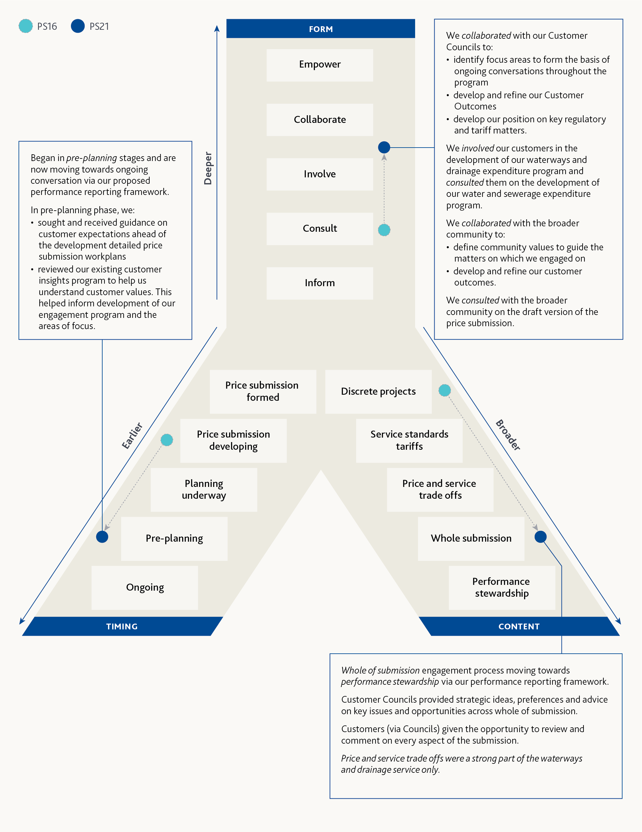
Engagement attribute | Level of engagement | What we have done differently
Form  Our Price Submission 2021 has moved to a deeper form of engagement, from consult to collaborate. | - Inform  - Consult  - Involve  - Collaborate  - Empower | We collaborated with our Customer Councils to:  - identify focus areas to form the basis of ongoing conversations throughout the program  - develop and reﬁne our Customer Outcomes  - develop our position on key regulatory and tariff matters.  We involved our customers in the development of our waterways and drainage expenditure program and consulted them on the development of our water and sewerage expenditure program.  We collaborated with the broader community to:  - deﬁne community values to guide the matters on which we engaged on  - develop and reﬁne our customer outcomes.  We consulted with the broader community on the draft version of the price submission.
Timing  Our Price Submission 2021 engaged earlier, moving from the development stage to pre-planning. | - Price submission formed  - Price submission developing  - Planning underway  - Pre-planning  - Ongoing | Began in pre-planning stages and are now moving towards ongoing conversation via our proposed performance reporting framework.  In pre-planning phase, we:  - sought and received guidance on customer expectations ahead of the development detailed price submission workplans  - reviewed our existing customer insights program to help us understand customer values. This helped inform development of our engagement program and the areas of focus.
Content  Our Price Submission 2021 engaged on broader topics, moving from discrete projects to whole submission. | - Discrete projects  - Service standards tariffs  - Price and service trade offs  - Whole submission  - Performance stewardship | Whole of submission engagement process moving towards performance stewardship via our performance reporting framework.  Customer Councils provided strategic ideas, preferences and advice on key issues and opportunities across whole of submission.  Customers (via Councils) given the opportunity to review and comment on every aspect of the submission.  Price and service trade offs were a strong part of the waterways and drainage service only.
Figure 2 - Engagement snapshot
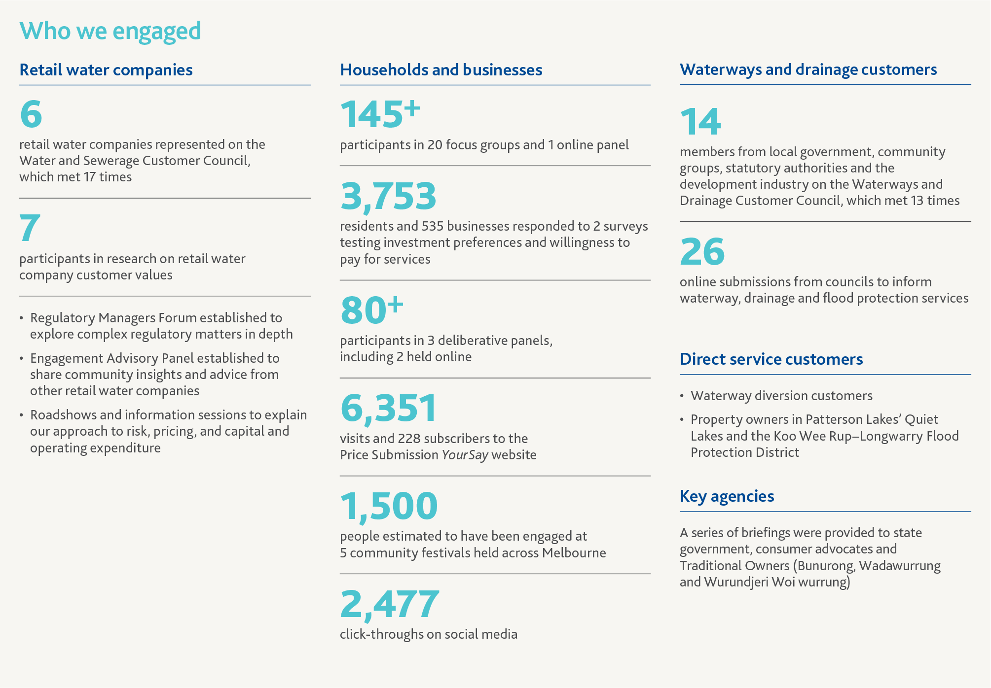
Who we engaged
- Retail water companies
  - 6 retail water companies represented on the Water and Sewerage Customer Council, which met 17 times
  - 7 participants in research on retail water company customer values
    - Regulatory Managers Forum established to explore complex regulatory matters in depth
    - Engagement Advisory Panel established to share community insights and advice from other retail water companies
    - Roadshows and information sessions to explain our approach to risk, pricing, and capital and operating expenditure
- Households and businesses
  - 145+ participants in 20 focus groups and 1 online panel
  - 3,753 residents and 535 businesses responded to 2 surveys testing investment preferences and willingness to pay for services
  - 80+ participants in 3 deliberative panels, including 2 held online
  - 6,351 visits and 228 subscribers to the Price Submission YourSay website
  - 1,500 people estimated to have been engaged at 5 community festivals held across Melbourne
  - 2,477 click-throughs on social media
- Waterways and drainage customers
  - 14 members from local government, community groups, statutory authorities and the development industry on the Waterways and Drainage Customer Council, which met 13 times
  - 26 online submissions from councils to inform waterway, drainage and flood protection services
- Direct service customers
  - Waterway diversion customers
  - Property owners in Patterson Lakes’ Quiet Lakes and the Koo Wee Rup–Longwarry Flood Protection District
- Key agencies
A series of briefings were provided to state government, consumer advocates and Traditional Owners (Bunurong, Wadawurrung and Wurundjeri Woi wurrung)
We established two dedicated customer forums – a Water and Sewerage Customer Council (WSCC) and a Waterways and Drainage Customer Council (WDCC) – as strategic engagement channels via which Melbourne Water sought insight into customer preferences, appropriate forms of engagement and other strategic matters as they arose. The Water and Sewerage Customer Council comprised representatives of our retail water company customers, while the Waterways and Drainage Customer Council comprised direct service (diverter) and waterways and drainage charge customers, as well as engaged community groups (for example Werribee and Yarra River Keeper associations), the State Emergency Service, the Victorian Planning Authority and Urban Development Institute of Australia, and local government.
These two forums worked collaboratively with us to help shape and refine both our engagement activities and our response to key service and regulatory matters. Our best offer has been heavily influenced by the work we undertook with these councils and we would like to acknowledge the time, energy and expertise they added to the development of this submission.
In Stage 1 – values and focus areas we set the scope of the engagement program and customer involvement. This stage shaped our understanding of customer values and areas of interest to be further explored through the engagement program. Insights drawn from this stage helped us to develop a preliminary set of customer outcome statements.
Stage 2 – preferences and performance sharpened the focus to customer preferences in relation to overall expectations of our performance (and the submission) as well as price-service trade-offs. During this stage we refined our customer outcomes, defined related outputs and measures, and explored customer preferences and willingness to pay for selected services.
In Stage 3 – validation our customers endorsed the proposed customer outcomes. We committed to the introduction of guaranteed service levels (GSLs) for our bulk water and sewerage services, and we finalised the investment programs needed to deliver on our customer outcomes.

Outcomes our customers value

We heard
Our engagement journey provided strong insight into customer preferences and what it is that they value and expect from our services. Our customers told us they:
- highly value our core services – in Stage 1 our community assessment of services highlighted the criticality of water to life, and in ensuring Melbourne can continue to thrive in the face of population growth and climate change
- want to see positive environmental and community outcomes from the services we provide and underpin
- don’t want us to lose sight of the ongoing affordability challenge
- expect services to be sustainable and in partnership with community
- expect us to take a forward view and be innovative
- want us to directly address climate change, including links to what Melbourne Water is doing to manage bushfire and drought risk, and address liveability and amenity
- want transparency in relation to what we do and how we do it, including future expenditure challenges.

We responded
To establish a strong link between our proposed actions and expenditure, and the preferences of our customers via customer outcomes, we enlisted the support of our customers and customer councils.
Over a three-stage process (separate to, but embedded within, the overarching engagement process outlined in Section 3.1) we:
Stage 1 – took early customer insights and developed seven draft customer outcomes
Stage 2 – refined seven outcomes to six via workshops with our customer councils
Stage 3 – tested the six draft final outcomes (and associated outputs and target metrics) via a deliberative panel using a representative sample of 43 households and businesses – the customers that we ultimately serve.
The insights we gained from this stage contributed to our understanding of the relative value our customers place on each outcome and were used to refine the wording of the final outcomes. Our customers (retail water companies and households and businesses) were highly supportive of the six final outcomes, and their associated outputs, presented on Figure 3 and Figure 4.
Our community deliberative panel explored the draft customer outcomes and provided both endorsement and insight into the priority they would assign each outcome. Specific insights from the deliberative panel phase included a need to focus on customer-friendly over technical language (for example ‘population growth’ made more sense to panel members than ‘urbanisation’) and the benefits of keeping outcomes simple and with a direct link to Melbourne to encourage connection with the outcome.
We engaged expert reviewers (such as KPMG) who encouraged us to simplify the language and ensure it reflects what customers will receive rather than what Melbourne Water will do, leaving any technical elements to the narrative or outputs.
We will deliver against the five service-oriented outcomes while ensuring (via our sixth outcome) we remain focused on household affordability now and into the future.
We also asked our customers (deliberative panel) what they thought of our output measures. While commenting that some were somewhat technical in nature, they were generally highly supportive of the measures we propose and the clarity with which we have presented them.
For 14 of our 15 output measures we received strong endorsement (between 60 per cent and 89 per cent of respondents indicated they “agreed” or “strongly agreed” with the statement that they support Melbourne Water using the proposed output to measure performance against the aligned outcome) of the proposed measure. Responses to a question about clarity of each output measure received similar levels of support. Output-specific customer ratings are presented in Section S3 of the Price Submission 2021 Supplement.
The other measures, relating to reduced flooding risk received 48 per cent support on the same basis with a further 40 per cent responding via a “neutral” rating. Given the somewhat technical nature of our flood mitigation work we intend to use the proposed measure for Price Submission 2021; however, we will use our performance reporting customer forum(s) to test and refine alternative measures over the course of the regulatory period.
Figure 3 - Customer outcomes summary (1 of 2)
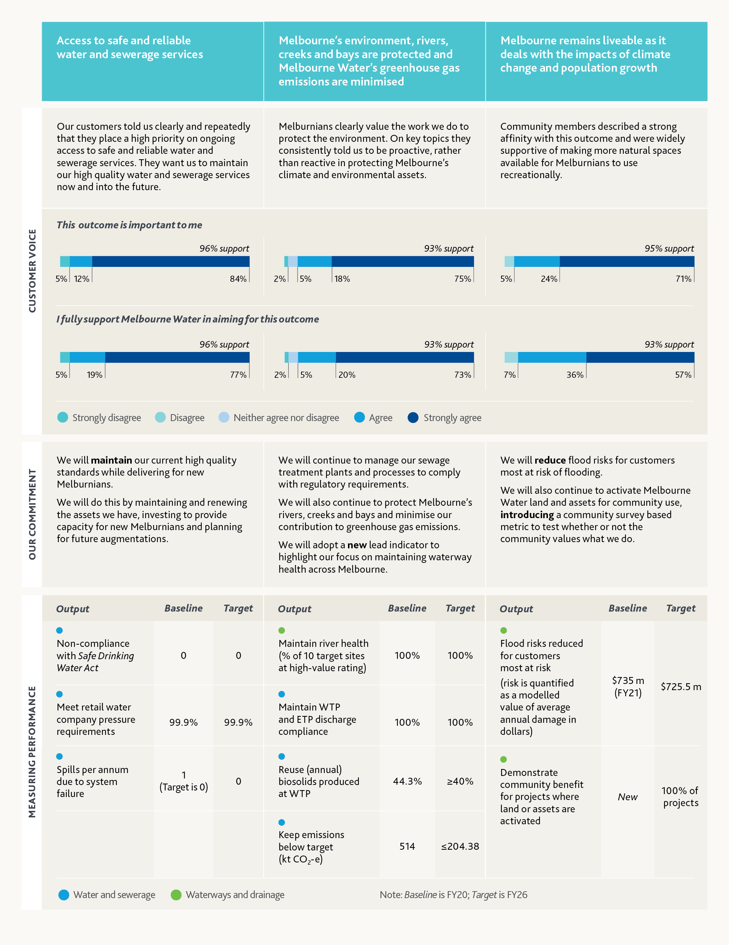
Access to safe and reliable water and sewerage services | Melbourne’s environment, rivers, creeks and bays are protected and Melbourne Water’s greenhouse gas emissions are minimised | Melbourne remains liveable as it deals with the impacts of climate change and population growth
Our customers told us clearly and repeatedly that they place a high priority on ongoing access to safe and reliable water and sewerage services. They want us to maintain our high quality water and sewerage services now and into the future. | Melburnians clearly value the work we do to protect the environment. On key topics they consistently told us to be proactive, rather than reactive in protecting Melbourne’s climate and environmental assets. | Community members described a strong afﬁnity with this outcome and were widely supportive of making more natural spaces available for Melburnians to use recreationally.
Customer voice:  This outcome is important to me:  - 5% strongly disagree  - 12% agree  - 84% strongly agree  - 96% support  I fully support Melbourne Water in aiming for this outcome:  - 5% strongly disagree  - 19% agree  - 77% strongly agree  - 96% support | Customer voice:  This outcome is important to me:  - 2% strongly disagree  - 5% neither agree nor disagree  - 18% agree  - 75% strongly agree  - 93% support  I fully support Melbourne Water in aiming for this outcome:  - 2% strongly disagree  - 5% neither agree nor disagree  - 20% agree  - 73% strongly agree  - 93% support | Customer voice:  This outcome is important to me:  - 5% strongly disagree  - 24% agree  - 71% strongly agree  - 95% support  I fully support Melbourne Water in aiming for this outcome:  - 7% strongly disagree  - 36% agree  - 57% strongly agree  - 93% support
Our commitment:  We will maintain our current high quality standards while delivering for new Melburnians.  We will do this by maintaining and renewing the assets we have, investing to provide capacity for new Melburnians and planning for future augmentations. | Our commitment:  We will continue to manage our sewage treatment plants and processes to comply with regulatory requirements.  We will also continue to protect Melbourne’s rivers, creeks and bays and minimise our contribution to greenhouse gas emissions.  We will adopt a new lead indicator to highlight our focus on maintaining waterway health across Melbourne. | Our commitment:  We will reduce ﬂood risks for customers most at risk of ﬂooding.  We will also continue to activate Melbourne Water land and assets for community use, introducing a community survey based metric to test whether or not the community values what we do.
Measuring performance:  - Output: Water and sewerage  Non-compliance with Safe Drinking Water Act  - Baseline: 0  - Target: 0  - Output: Water and sewerage  Meet retail water company pressure requirements  - Baseline: 99.9%  - Target: 99.9%  - Output: Water and sewerage  Spills per annum due to system failure  - Baseline: 1 (Target is 0)  - Target: 0  Note: Baseline is FY20; Target is FY26 | Measuring performance:  - Output: Waterways and drainage  Maintain river health (% of 10 target sites at high-value rating)  - Baseline: 100%  - Target: 100%  - Output: Water and sewerage  Maintain Western Treatment Plant and Eastern Treatment Plant discharge compliance  - Baseline: 100%  - Target: 100%  - Output: Water and sewerage  Reuse (annual) biosolids produced at Western Treatment Plant  - Baseline: 44.3%  - Target: Greater than or equal to 40%  - Output: Water and sewerage  Keep emissions below target  (kt CO₂-e)  - Baseline: 514  - Target: Less than or equal to 204.38  Note: Baseline is FY20; Target is FY26 | Measuring performance:  - Output: Waterways and drainage  Flood risks reduced for customers most at risk (risk is quantiﬁed as a modelled value of average annual damage in dollars)  - Baseline: $735m (FY21)  - Target: $725.5m  - Output: Waterways and drainage  Demonstrate community beneﬁt for projects where land or assets are activated  - Baseline: New  - Target: 100% of projects  Note: Baseline is FY20; Target is FY26
Figure 4 - Customer outcomes summary (2 of 2)
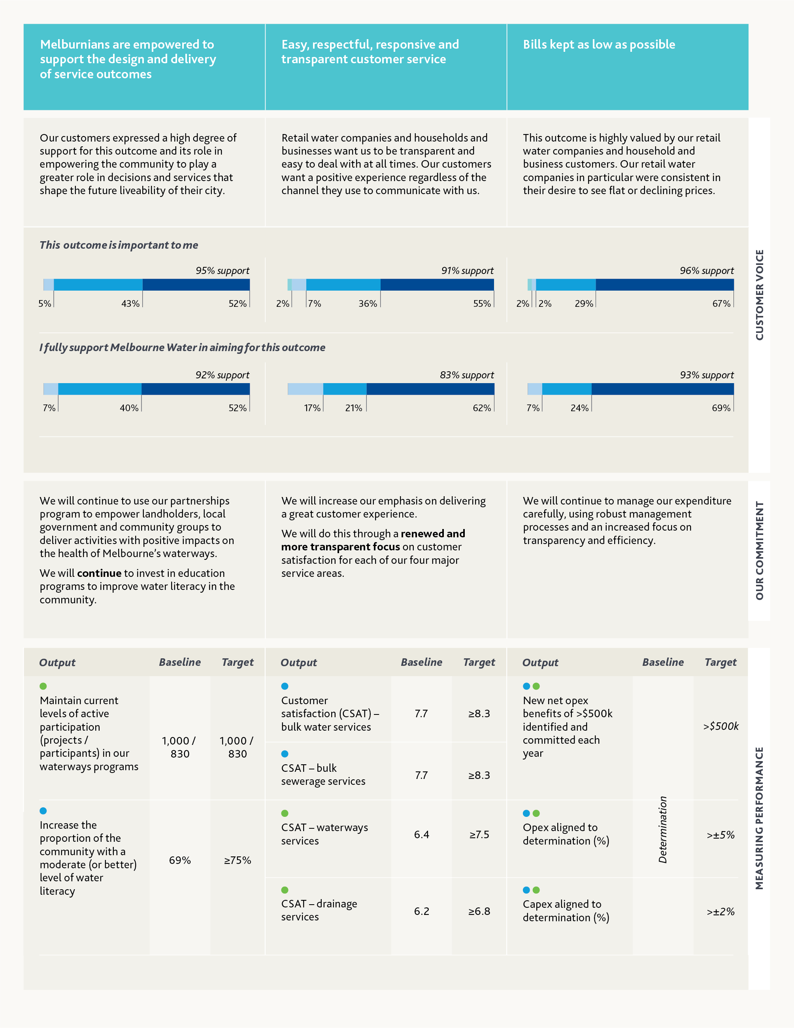
Melburnians are empowered to support the design and delivery of service outcomes | Easy, respectful, responsive and transparent customer service | Bills kept as low as possible
Our customers expressed a high degree of support for this outcome and its role in empowering the community to play a greater role in decisions and services that shape the future liveability of their city. | Retail water companies and households and businesses want us to be transparent and easy to deal with at all times. Our customers want a positive experience regardless of the channel they use to communicate with us. | This outcome is highly valued by our retail water companies and household and business customers. Our retail water companies in particular were consistent in their desire to see ﬂat or declining prices.
Customer voice:  This outcome is important to me:  - 5% neither agree nor disagree  - 43% agree  - 52% strongly agree  - 95% support  I fully support Melbourne Water in aiming for this outcome:  - 7% neither agree nor disagree  - 40% agree  - 52% strongly agree  - 92% support | Customer voice:  This outcome is important to me:  - 2% strongly disagree  - 7% neither agree nor disagree  - 36% agree  - 55% strongly agree  - 91% support  I fully support Melbourne Water in aiming for this outcome:  - 17% neither agree nor disagree  - 21% agree  - 62% strongly agree  - 83% support | Customer voice:  This outcome is important to me:  - 2% strongly disagree  - 2% neither agree nor disagree  - 29% agree  - 67% strongly agree  - 96% support  I fully support Melbourne Water in aiming for this outcome:  - 7% neither agree nor disagree  - 24% agree  - 69% strongly agree  - 93% support
Our commitment:  We will continue to use our partnerships program to empower landholders, local government and community groups to deliver activities with positive impacts on the health of Melbourne’s waterways.  We will continue to invest in education programs to improve water literacy in the community. | Our commitment:  We will increase our emphasis on delivering a great customer experience.  We will do this through a renewed and more transparent focus on customer satisfaction for each of our four major service areas. | Our commitment:  We will continue to manage our expenditure carefully, using robust management processes and an increased focus on transparency and efﬁciency.
Measuring performance:  - Output: Waterways and drainage  Maintain current levels of active participation (projects / participants) in our waterways programs  - Baseline: 1,000 / 830  - Target: 1,000 / 830  - Output: Water and sewerage  Increase the proportion of the community with a moderate (or better) level of water literacy  - Baseline: 69%  - Target: Greater than or equal to 75%  Note: Baseline is FY20; Target is FY26 | Measuring performance:  - Output: Water and sewerage  Customer satisfaction (CSAT) – bulk water services  - Baseline: 7.7  - Target: Greater than or equal to 8.3  - Output: Water and sewerage  CSAT – bulk sewerage services  - Baseline: 7.7  - Target: Greater than or equal to 8.3  - Output: Waterways and drainage  CSAT – waterways services  - Baseline: 6.4  - Target: Greater than or equal to 7.5  - Output: Waterways and drainage  CSAT – drainage services  - Baseline: 6.2  - Target: Greater than or equal to 6.8  Note: Baseline is FY20; Target is FY26 | Measuring performance:  - Output: Water and sewerage, and Waterways and drainage  New net opex beneﬁts of >$500k identiﬁed and committed each year  - Baseline: Determination  - Target: Greater than $500k  - Output: Water and sewerage, and Waterways and drainage  Opex aligned to determination (%)  - Baseline: Determination  - Target: Greater than and plus or minus 5%  - Output: Water and sewerage, and Waterways and drainage  Capex aligned to determination (%)  - Baseline: Determination  - Target: Greater than and plus or minus 2%  Note: Baseline is FY20; Target is FY26

Other customer-centric commitments
Our customers shared their preferences in relation to a number of other matters. What we heard and how we responded is outlined below.

We heard

Outcomes performance reporting
- Our retail water company and household and business customers were unified in their desire for transparent reporting and clear accountability for performance – a strong customer-centric focus was evident in their responses to the question of how Melbourne Water should manage performance reporting and changing customer preferences.
- Supplementing these views, the Waterways and Drainage Customer Council supported the concept of an ongoing customer council-style body. It felt that a customer-centric approach to reporting and performance was important.

Water and Sewerage Customer Council accountability and transparency preferences
- Throughout our 18-month collaboration with the Water and Sewerage Customer Council we heard and responded to many requests for information and greater clarity around our service delivery challenges and proposals. While the majority of these responses were managed along the way, the Water and Sewerage Customer Council also challenged us to commit to greater accountability and transparency, in particular via the introduction of guaranteed service levels and a comprehensive review of our tariff structures.

Victorian Desalination Plant – capitalisation of security payments
- The Water and Sewerage Customer Council told us they support the principle of intergenerational equity and stated that the status quo did not represent an equitable approach. In line with their desire to deliver flat prices over time, they encouraged us to explore alternative capitalisation profiles and timings (including a stepped approach) that support this pricing outcome.

We responded
Price Submission 2021 represents a step change to the way in which Melbourne Water views its commitments made via a price submission and the impact this has on its customers. The following key customer-centred initiatives have been developed in direct response to what we heard from our customers.
- We acknowledge the strong desire of our customers for transparent and accountable delivery against our Price Submission 2021 commitments. We will act via a customer-centric approach to outcomes performance reporting and management.
We intend that this will take the form of an ongoing customer council-style forum (or forums) meeting at least once a year. Ideally comprising representatives of our household, business and retail water company customer segments, the forum(s) will enable us to understand and test customer preferences as they relate to the services we provide. We intend to use this ongoing conversation to:
  - facilitate transparent reporting of performance against our outcomes directly to our customers (we will also publish an annual performance report on our website and communicate this via social media)
  - engage with our customers over an appropriate Melbourne Water response to underperformance (or over-performance) in relation to customer outcomes – this may include consideration of additional (non-customer-funded) expenditure to rectify an underperformance against our customer outcomes, and/or consideration of the circumstances under which it would be appropriate for Melbourne Water to make repayments to customers (for example, chronic underperformance against outcomes)
  - ensure our priorities continue to be aligned with customer preferences, and help us identify the most appropriate strategies to respond to emerging or unexpected issues
  - prepare for our next price submission in 2025 – with the expectation that as we move into pre-planning for Price Submission 2026 (PS26) we would meet more regularly with the forum(s).
- We will introduce guaranteed service levels for the first time for our bulk water and sewerage services. The introduction of guaranteed service levels (emerging concept outlined in Table 2) represents a step change to the way in which we manage customer interests in delivering our vital services. They represent a new approach for the way we manage our services and our relationship with retail water companies.
Key features of the emerging guaranteed service level concept include metrics that:
  - have a clear link to our services and their contribution to the household and business customer experience
  - align with what we heard from retail water companies during our engagement phase
  - align with existing retail water company guaranteed service levels (including payment amount levels)
  - use existing processes to identify and pay affected household and business customers (Melbourne Water to reimburse retail water companies).
Demonstrating the sincerity of our offer to deepen our service commitment to our customers in this way, we worked with our retail water company customers to define appropriate guaranteed service levels via a considered and highly collaborative process.
Table 2 - Guaranteed service levels under consideration – bulk water and sewerage
Guaranteed service level | Customer impact | Indicative payment
Planned event – breach of minimum notice period (for example, change of water source) | Household or business impact – unexpected loss of amenity (for example change in taste, odour of water supply) | Match retail water company payment – in order of $50 to household or business customer
Planned event – breach of minimum notice period (for example, change of water source) | Retail water companies’ impact – additional management of customer calls/complaints | $5,000 per incident per affected retail water company
Unplanned water or sewerage service disruption/event | Household or business impact – unexpected loss of service or amenity | Match retail water company payment – in order of $50 to $200 to household or business customer
Pressure deviations above tolerances | Damage to retail water company infrastructure | Actual cost >$10,000 per incident to retailer
Sewage spill (caused by system failure) | Household or business premises or local environment | Match retailer payment to end customer in order of $1,000-$3,000
We spent time in June and July 2020 working collaboratively with metropolitan retail water companies to explore what is possible/practicable, leading to the development of a concept and prototype process in August 2020. We will continue to develop the details of the guaranteed service level concept and plan for implementation on 1 July 2021. We will provide further detail during the Essential Services Commission’s review stage.
- We will initiate a comprehensive review of our tariff structures. Responding directly to a request from the Water and Sewerage Customer Council, Melbourne Water is also committing to the conduct of a review of our tariffs, to conclude not later than October 2022. This timeline is proposed with the express support of our retail water company customers, with the intent that it provides the opportunity to align the implementation of any changes with the commencement of their next regulatory period in 2023.
While individual retail water companies presented mixed views on perceived issues with the existing tariff structure, the review is intended to explore opportunities to reform our existing tariffs to better deliver on the principles contained within the Water Industry Regulatory Order.
In relation to the introduction of guaranteed service levels and the conduct of the tariff structure review we propose to report on progress on these matters via the proposed customer forum(s). Ultimately, we accept that failure to deliver against these commitments will detract from our “performance” assessment as part of our next price submission.
- We will deliver a more equitable customer treatment of the Victorian Desalination Plant security payments in line with the feedback we received from the Water and Sewerage Customer Council.
Through the combination of lease repayments and capitalisation introduced in Price Submission 2016, Melbourne Water has already begun the journey to a more equitable customer repayment profile.
We propose to significantly increase the amount we capitalise in Price Submission 2021, aligning the amount we capitalise each year with the annual amounts assumed as capital (principal) payments for tax purposes. This approach represents a far more equitable customer repayment profile over the life of the asset and aligns with the Water and Sewerage Customer Council’s stated support for intergenerational equity. We will capitalise $399 million over the regulatory period, an increase of $235 million from Price Submission 2016, delivering a reduction in our required revenue of $217 million.
Melburnians today will benefit via lower Victorian Desalination Plant charges. Future Melburnians will contribute a more equitable share of the asset cost after the expiry of the current lease – reflecting the ongoing benefits the plant will provide to them.

Robust and collaborative demand forecasts
We undertook a robust demand forecasting approach for Price Submission 2021 that was tailored to each of our three major service areas. Growth forecasts for each service are either underpinned by, or aligned with, the Victoria in Future 2019 data series. We also engaged KPMG to conduct a multistage review to test and challenge the demand forecasting process and underlying assumptions. Material improvements to the transparency and quality of supporting data were made following these reviews and a number of key assumptions were either revisited or amended.
Our demand forecasting approach and final demand forecasts are detailed in Section S5 of the Price Submission 2021 Supplement, along with key reference documents that are available upon request.
As outlined in Section 2.1 our submission adopts our “original best estimate” demand and expenditure forecasts. We will absorb the net loss of revenue in the event these forecasts overestimate actual demand growth.

Waterways and drainage
- Recognising the challenges associated with applying a one-size-fits-all forecast to property growth, we adapted our property forecasting methodology in Price Submission 2021 to take into account more data points and the need for residential, non-residential and rural-specific assumptions. We examined a range of data sources in the development of final property growth forecasts, ultimately applying projections provided by expert property development forecaster BIS Oxford Economics on the basis that they represent the best local area view of growth and are in line with the Victoria in Future 2019 and retail water company forecasts.

Water
- As a wholesaler we rely on our retail water company customers to develop our demand forecasts. Our Price Submission 2021 water forecasts represent an aggregation of recent forecasts developed by the retail water companies. We request and examine key underlying assumptions made by each retail water company, applying a materiality test to the question of whether or not further refinement or clarification of assumptions is required. This is a continuation of the methodology we applied in developing our Price Submission 2016 forecasts.
- Our water forecasts are described in detail in Section S5.3 of the Price Submission 2021 Supplement. They show that the megalitres of water sold will grow on average 0.83 per cent per annum from the 2018-19 base year to the end of the Price Submission 2021 regulatory period. We are comfortable that the underlying assumptions are reasonable and reflect the underlying trends of more water connections, with a declining consumption per connection. This latter trend is due to a combination of retail water company end use model assumptions around new properties being (on average) smaller, with less outdoor water usage, and the overall stock of water-using appliances becoming more efficient over time.

Sewage
- Demand forecasting for sewage is inherently more uncertain than demand forecasting for water or property as a result of a number of factors, including five parameters requiring measurement (rather than one), great number and diversity of sources of sewage (over 1 million household and commercial connections plus industrial connections), and the absence of comprehensive property-level metering. Unlike water, where every connection is metered, measurement of sewage flows and loads occurs at a limited number of locations.
- Applying our continuous improvement ethos, and responding to the sewage forecasting challenge outlined above, we applied a new, and highly collaborative methodology to the development of our forecasts for Price Submission 2021. This methodology is outlined in detail in Section S5.4 of the Price Submission 2021 Supplement and moves our forecasts from the aggregation of individual methodology outputs (Price Submission 2016) to the application of a common methodology with agreed assumptions underpinning retail water company forecasts.
- Our sewage forecasts show growth in the megalitres of sewage treated of, on average, 0.51 per cent per annum (Eastern Treatment Plant) and 1.03 per cent per annum (Western Treatment Plant) from the 2018-19 base year to the end of the Price Submission 2021 regulatory period. Treatable load parameters – which are a more material driver of treatment plant costs – are also forecast to grow:
  - total suspended solids (TSS) growth is forecast to be 1.29 per cent per annum at Eastern Treatment Plant and 1.94 per cent per annum at Western Treatment Plant
  - biological oxygen demand (BOD) growth is forecast to be 0.99 per cent per annum at Eastern Treatment Plant and 1.46 per cent per annum at Western Treatment Plant
  - total Kjeldahl nitrogen (TKN) growth is forecast to be 1.11 per cent per annum at Eastern Treatment Plant and 1.90 per cent per annum at Western Treatment Plant.

Focused and disciplined governance
Delivering on the customer outcomes requires us to deliver a mixture of asset and non-asset-based activities. These activities form the basis for our expenditure forecasts, which in turn form the basis (along with our regulatory asset base (RAB) for the prices we ultimately charge for our services.
Ensuring our proposal and expenditure forecasts are prudent and balanced in terms of risk requires consideration of a range of factors including asset condition, service and regulatory standards, and demand for our services – both in terms of current and future customers.

Strong internal discipline
Our Board and Leadership Team were central to the planning and delivery of this submission, challenging every part of the organisation to put forward a “best offer” that puts our customers first.
Our Board, and in particular the Customer and Service Delivery Committee (CSDC) and Audit, Risk and Finance Committee (ARFC), were actively involved in the development, review and approval of this submission.
Through a comprehensive briefing program which commenced in the early phases of submission development, the Board was both abreast of, and able to shape, key aspects of the submission including our approach to customer engagement, the alignment of expenditure proposals to customer outcomes, regulatory matters such as length of regulatory period, and the appropriate treatment of Victorian Desalination Plant payments.
The Board’s involvement in developing and reviewing the submission spanned a period of over 30 months, with the frequency and depth of involvement increasing significantly in the final stages of document completion.
In addition to regular briefings the Board members took an active interest in our engagement activities with customers. This included some Board members observing our final waterways and drainage community deliberative panel on Saturday 18 April 2020, and our final customer outcomes community deliberative forum held from 22-29 April 2020. Both of these were conducted online as a result of COVID-19 restrictions.
These actions, and the whole-of-organisation response to the Board and Leadership Team’s guidance, means Price Submission 2021 sets a new benchmark for Melbourne Water price submissions in terms of rigour and oversight (internal and Board).

Robust governance and assurance
The PREMO framework demands a more conspicuous and considered management and Board involvement around quality and accuracy of submission. Our assurance activities included a combination of internal and independent reviews from KPMG and other independent advisors, allowing for iterative review and approval of input information.
We worked closely with KPMG via its specialist regulated utilities team for well over 18 months to design and deliver a robust submission. KPMG provided staged guidance and then review of the planning, design, development and finalisation of our pricing submission and supporting documents, challenging key aspects of the development of our customer outcomes, demand, capex and opex forecasts, and supporting the overarching assurance process.
Our Internal Audit function oversaw responses to KPMG recommendations, ensuring that improvement actions were delivered as instructed by the Board and Leadership Team.
We also developed and applied a robust governance and assurance framework that set out purposeful and timely internal review and assurance activities, including:
- leadership involvement and accountability through a steering committee chaired by our Managing Director and meeting quarterly in 2019 and monthly in 2020
- defined roles and accountabilities, with a dedicated program director, program manager, workstream leads and a working group comprising senior leaders with overarching responsibility for water, sewerage, and waterways and drainage service-related outcomes
- monthly assurance reports developed to provide status updates against attestation requirements for core submission components
- iterative Leadership Team expenditure review and challenge processes
- steering committee review of the emerging draft submission and key proposals
- iterative Internal Audit Team review against each of the Essential Services Commission guideline requirements
- review of the accuracy of financials, including consistency between the pricing submission and the supporting financial templates
- a comprehensive attestation process undertaken with the Board reviewing and challenging the suite of internal and external activities undertaken to facilitate attestation.
The significant focus on developing and implementing a robust assurance framework and process provided the Board and Leadership Team with high levels of confidence that all reasonable steps had been taken to meet each of the three attestation conditions.

What our commitment to strong internal discipline means for customers
Oversight by the Leadership Team and Board has directly shaped our expenditure programs with a robust challenge process running from November 2019 to August 2020, helping to refine the scope, scale and timing of our capital program and opex forecasts. As a result of the internal discipline we applied to our expenditure forecasts we have reduced our capital program by $498 million since November 2019, predominantly via a series of scope reductions and deferrals (for example, the Bunyip River Diversion Project and Eastern Treatment Plant Sludge Drying Capacity Augmentation – $104 million deferred to the next regulatory period).

A prudent and efficient investment program
We will invest prudently and efficiently (both capex and opex) to deliver the outcomes our customers have told us they value. Table 3 shows our proposed capex program along with a comparison to our Price Submission 2016 forecast.
- The uplift in capex from Price Submission 2016 to Price Submission 2021 is one obvious way in which we are responding to the challenges outlined in Section 2.2.
  - We are delivering for a growing population. While taking into account forecast growth over the next five years and beyond, our growth capex is primarily a response to strong population growth over the past five years. A number of critical assets (particularly at the Western Treatment Plant) have absorbed the additional demand generated by the half a million people who have been added to Melbourne’s population since 2016 and now require augmentation. These assets (see Table 13 and Table 14 in Attachment 1) are currently at or exceeding critical design and compliance limits and require augmentation now.
  - We are investing to keep the assets we already have fit-for-purpose as they age and deal with the challenges presented by climate change (for example, accelerated corrosion). Our renewals capex growth is driven in part by a large atypical sewer main renewal project (Hobsons Bay Main Yarra Crossing Duplication) which is $100 million larger than the next largest renewals project. It is also driven by our ongoing focus on prudently managing the assets we have. For example, over the past five years an increased focus on condition monitoring has shown that our concrete sewers are deteriorating faster than anticipated. This insight, along with failure incidents (for example a Maribyrnong River Main event in late 2017), has led to a recalibration of how we plan sewer transfer renewals on a large portfolio of aging assets. This means increasing our focus on early intervention, such as relining small sewers and increasing ventilation in large sewers, in order to defer or avoid far more costly whole-of-asset replacements.
  - We are investing to deliver the levels of service our customers have told us they desire and are willing to pay for. This is evident in the waterways and drainage “improvement” category, where the majority of the capex uplift is the result of customer-led uplifts in stormwater quality management. Customer support for higher levels of service is outlined in Section 3.6 (and detailed in Section S2.3.3 of the Price Submission 2021 Supplement).
- Our capital program is underpinned by robust business cases, and the use of risk-adjusted nominal estimates followed by Monte Carlo simulation to generate P50 estimates, which form the basis for the values shown in Table 3.
- To keep customer bills as low as possible, and reflecting our ongoing commitment to continuous improvement, we are committing to achieving a base controllable opex forecast that is declining at 0.05 per cent per annum across the period while supporting a growing population (Table 4).
- Our opex will also grow to incorporate the new assets we have built in Price Submission 2016 and will build in Price Submission 2021, along with meeting new obligations. Table 4 presents both our five-year opex forecast as well as the derivation of our efficient controllable base year at a whole of Melbourne Water level. Similar views, by service, are presented in Section S6.1.4 and Section S6.1.5 of the Price Submission 2021 Supplement.
Figure 5 shows the impacts of our opex forecasts on the typical customer using a dollar-per-customer metric. Figure 6 shows an underlying regulated asset base-per-customer metric which forms the basis for our depreciation and return-to-capital allowances – this figure does not show direct customer price impacts. These two figures show that our opex per customer will decline across the period, while our regulated asset base per customer will grow modestly to be 3.9 per cent above 2019-20 levels by 2025-26.
Table 3 - Price Submission 2016 to Price Submission 2021 comparison of capex by major service by driver (excluding Corporate)
Item | Price Submission 2016  (refer Note 1) | Price Submission 2021 | Percentage change
Water and sewerage (refer Note 2) | N/A | N/A | N/A
Growth | $306.7m | $824.4m | 169%
Renewals | $820.6m | $1,017.3m | 24%
Improvement/Compliance | $463.0m | $480.2m | 4%
Totals | $1,590.3m | $2,321.9m | 46%
Waterways and drainage (refer Note 3) | N/A | N/A | N/A
Growth | $591.7m | $701.2m | 19%
Renewals | $105.1m | $119.5m | 14%
Improvement/Compliance | $265.1m | $399.1m | 51%
Totals | $961.9m | $1,219.8m | 27%
Combined totals | $2,552.2m | $3,541.7m | 39%
Note 1: Price Submission 2016 numbers include actuals and forecast and therefore do not reconcile with the Essential Services Commission’s financial template, which includes determination values for the 2020-21 year, rather than forecast.
Note 2: Includes one project ($0.093 million) that is allocated to the recycled water service.
Note 3: Includes one project ($2.14 million) that is allocated to the diversions service.

Table 4 - Price Submission 2021 opex forecast and efficient base year ($ million)
Note: Numbers may not add due to rounding
Item | Details | Base  2019-20 | Current 2020-21 | Price Submission 2021 Regulatory Period 2021-22 | Price Submission 2021 Regulatory Period 2022-23 | Price Submission 2021 Regulatory Period 2023-24 | Price Submission 2021 Regulatory Period 2024-25 | Price Submission 2021 Regulatory Period 2025-26 | Price Submission Total | CAGR  2019-20 to 2025-26
Overall forecast | Total base year opex | $1,008.6 | N/A | N/A | N/A | N/A | N/A | N/A | N/A | N/A
Post capitalisation | Victorian Desalination Plant security payments (A) | $587.4 | $544.5 | $493.1 | $485.2 | $473.0 | $457.0 | $443.9 | $2,352.2 | (4.6%)
Uncontrollable opex | Water and sewerage | N/A | N/A | N/A | N/A | N/A | N/A | N/A | N/A | N/A
Uncontrollable opex | Land tax, licence fees | $24.9 | $22.6 | $21.9 | $21.9 | $21.9 | $21.9 | $21.9 | N/A | N/A
Uncontrollable opex | Waterways and drainage | N/A | N/A | N/A | N/A | N/A | N/A | N/A | N/A | N/A
Uncontrollable opex | Land tax, licence fees, environmental contribution levy | $9.0 | $8.0 | $8.7 | $8.6 | $8.6 | $8.6 | $8.6 | N/A | N/A
Uncontrollable opex | Total uncontrollable opex (B) | $33.9 | $30.6 | $30.6 | $30.6 | $30.5 | $30.5 | $30.5 | $152.7 | (1.7%)
Controllable opex (efficient base derivation) | 2019-20 baseline (gross) | $387.3 | N/A | N/A | N/A | N/A | N/A | N/A | N/A | N/A
Controllable opex (efficient base derivation) | (less) electricity | ($44.8) | ($46.3) | ($43.5) | ($39.7) | ($42.8) | ($44.3) | ($50.7) | N/A | N/A
Controllable opex (efficient base derivation) | add base year adjustments | $4.1 | N/A | N/A | N/A | N/A | N/A | N/A | N/A | N/A
Controllable opex (efficient base derivation) | 2019-20 baseline (net) | $346.6 | N/A | N/A | N/A | N/A | N/A | N/A | N/A | N/A
Controllable opex (efficient base derivation) | Efficiency factor | N/A | (2.00%) | (2.00%) | (2.00%) | (2.00%) | (2.00%) | (2.00%) | N/A | N/A
Controllable opex (efficient base derivation) | Growth factor | N/A | 1.80% | 1.95% | 1.95% | 1.95% | 1.95% | 1.95% | N/A | N/A
Controllable opex (efficient base derivation) | Efficient base year (target) | N/A | $345.9 | $345.7 | $345.5 | $345.3 | $345.2 | $345.0 | $1,726.7 | N/A
Controllable opex (efficient base derivation) | Efficient base year forecast | N/A | $345.7 | $345.5 | $345.3 | $345.2 | $345.0 | $1,726.7 | N/A | N/A
Controllable opex (efficient base derivation) | Benchmark electricity allowance | $26.3  (refer Note a) | N/A | $28.3 | $28.1 | $28.1 | $29.8 | $33.0 | $147.3 | N/A
Controllable opex (efficient base derivation) | Water and sewerage | N/A | N/A | N/A | N/A | N/A | N/A | N/A | N/A | N/A
Controllable opex (efficient base derivation) | Additions to efficient base year | N/A | N/A | $4.9 | $3.0 | $4.3 | $7.6 | $8.3 | N/A | N/A
Controllable opex (efficient base derivation) | Waterways and drainage | N/A | N/A | N/A | N/A | N/A | N/A | N/A | N/A | N/A
Controllable opex (efficient base derivation) | Additions to efficient base year | N/A | N/A | $0.9 | $0.9 | $0.9 | $0.6 | $0.6 | N/A | N/A
Controllable opex (efficient base derivation) | Willingness-to-pay | N/A | N/A | $7.8 | $8.0 | $8.3 | $9.5 | $9.9 | N/A | N/A
Controllable opex (efficient base derivation) | Total controllable opex (C) | $372.9  (refer Note a) | N/A | $387.5 | $385.5 | $387.0 | $392.6 | $396.8 | $1,949.4 | 1.0%
Total regulatory opex =  (A) + (B) + (C) | N/A | $994.2  (refer Note a) | N/A | $911.2 | $901.3 | $890.5 | $880.2 | $871.2 | $4,454.4 | (2.2%)
Note a: These values are shown to enable calculation of the CAGR rate shown at far right. Total controllable opex differs from Essential Services Commission template as it is calculated on the regulatory allowance, while the template shows actual electricity expenditure for 2019-20.
Figure 5 - Opex per customer – 2015-16 to the end of Price Submission 2021
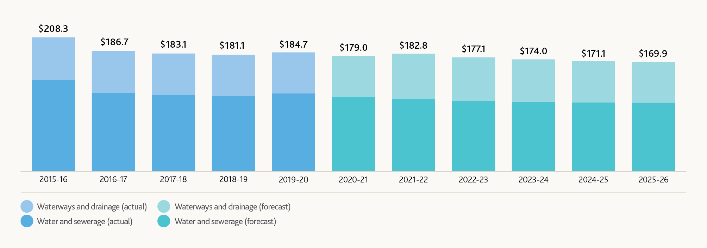
Item | 2015-16 | 2016-17 | 2017-18 | 2018-19 | 2019-20 | 2020-21 | 2021-22 | 2022-23 | 2023-24 | 2024-25 | 2025-26
Water & sewerage (Actual) | $141.9 | $121.4 | $118.9 | $116.6 | $121.0 | N/A | N/A | N/A | N/A | N/A | N/A
Waterways and drainage (Actual) | $66.3 | $65.4 | $64.2 | $64.5 | $63.8 | N/A | N/A | N/A | N/A | N/A | N/A
Water & sewerage (Forecast) | N/A | N/A | N/A | N/A | N/A | $115.5 | $112.7 | $109.1 | $107.8 | $107.1 | $106.8
Waterways and drainage (Forecast) | N/A | N/A | N/A | N/A | N/A | $63.6 | $70.1 | $68.0 | $66.2 | $64.1 | $63.0
Label | $208.3 | $186.7 | $183.1 | $181.1 | $184.7 | $179.0 | $182.8 | $177.1 | $174.0 | $171.1 | $169.9
Figure 6 - Closing regulated asset base per customer – 2015-16 to the end of Price Submission 2021
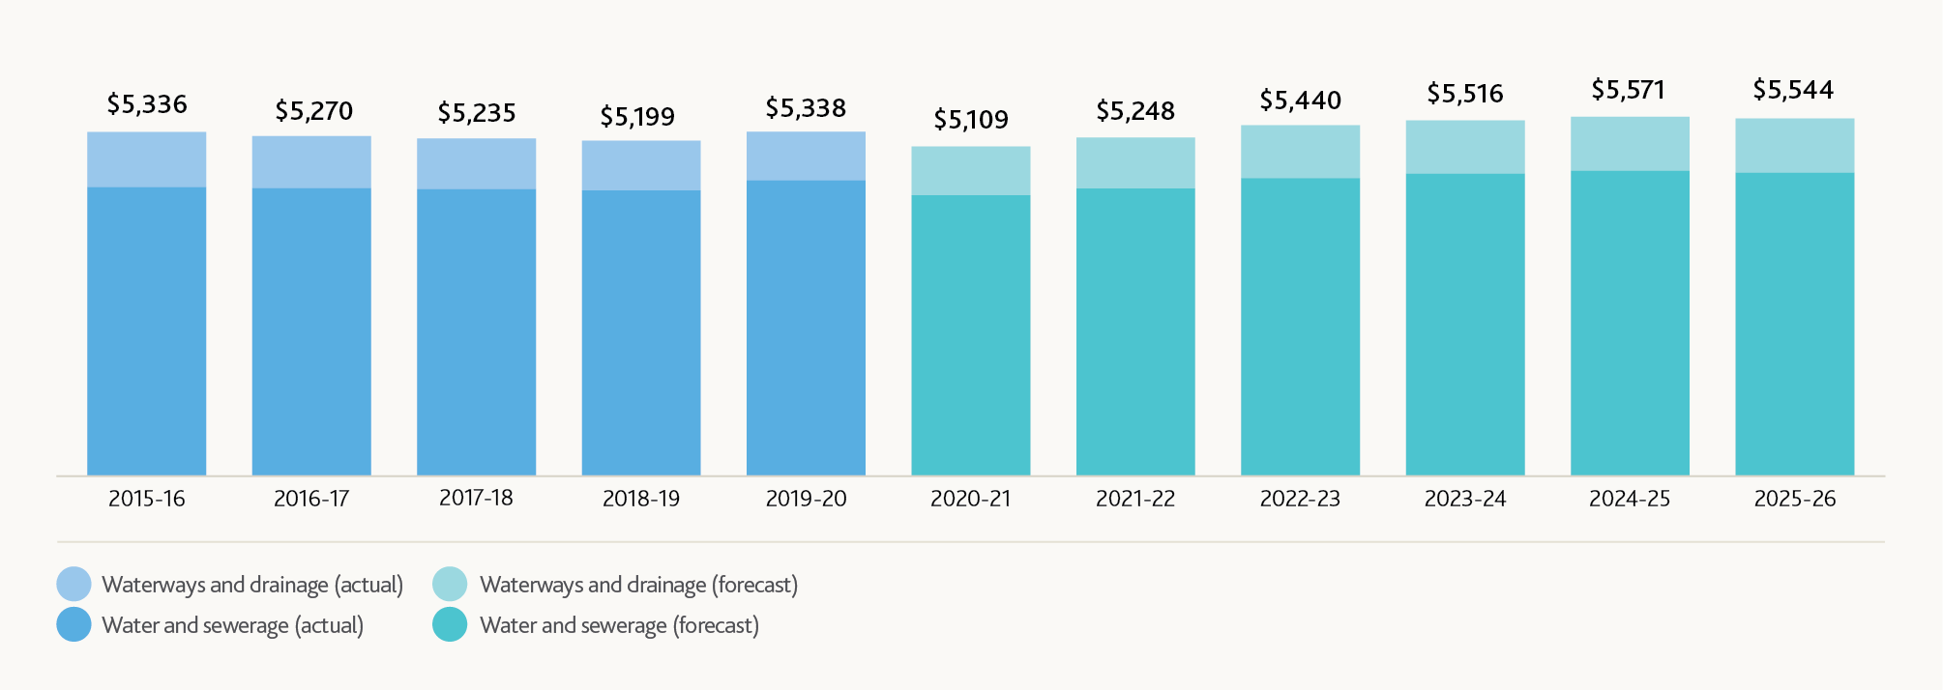
Item | 2015-16 | 2016-17 | 2017-18 | 2018-19 | 2019-20 | 2020-21 | 2021-22 | 2022-23 | 2023-24 | 2024-25 | 2025-26
Water & sewerage (Actual) | $4,480.03 | $4,463.81 | $4,447.98 | $4,426.70 | $4,584.37 | N/A | N/A | N/A | N/A | N/A | N/A
Waterways and drainage (Actual) | $855.82 | $806.63 | $787.21 | $772.80 | $753.30 | N/A | N/A | N/A | N/A | N/A | N/A
Water & sewerage (Forecast) | N/A | N/A | N/A | N/A | N/A | $4,353.88 | $4,458.67 | $4,619.88 | $4,687.20 | $4,731.42 | $4,701.09
Waterways and drainage (Forecast) | N/A | N/A | N/A | N/A | N/A | $755.31 | $789.50 | $820.21 | $829.14 | $839.63 | $843.23
Label | $5,336 | $5,270 | $5,235 | $5,199 | $5,338 | $5,109 | $5,248 | $5,440 | $5,516 | $5,571 | $5,544
Per customer values shown are based on City West Water, South East Water, Yarra Valley Water and Western Water customer data.

Careful balancing of risk
Melbourne Water undertook a robust process to identify and assess material uncertainties relating to the provision of our services for Price Submission 2021. This included consideration of management/mitigation options and who bears the residual risks post mitigation.
We started the consideration of risks for Price Submission 2021 with reference to Melbourne Water’s risk management processes guided by our Risk Management Team. We engaged with senior managers across the business, including representatives from our Operational, Capital Planning and Delivery, Customer and Strategy and Finance functions.
Our senior leaders, Leadership Team and customers (via the Water and Sewerage Customer Council) have been central to the consideration and shaping of our response to the risks presented below.
Our Board and Leadership Team were unambiguously focused on ensuring that our expenditure decisions do not ask our customers to fund costs associated with highly uncertain events or activities.
We have also carefully considered the implications of COVID-19 on our submission (Section 2.1) and acted to ensure our customers are not paying for any additional uncertainty caused by the pandemic.
Price Submission 2021 materially increases the risk that we are absorbing on behalf of customers compared to our prior regulatory submissions, including via:
- “smoothing” the capex profile. We have taken this decision to acknowledge that there is increased delivery risk associated with our larger capital program (compared to Price Submission 2016) and that this may be exacerbated by COVID-19 in the near term. The effect of this decision is to “shift” $271.3 million from years one and two, into years three ($9.3 million), four ($45.3 million) and five ($216.6 million) – reducing our aggregate revenue requirement by $42.9 million
- compared to prior price submissions, Price Submission 2021 transfers considerable risk from our customers back to Melbourne Water in our opex forecasts in order to deliver a declining year-on-year base controllable opex, including via:
  - application of a 3 per cent labour vacancy rate in the build-up of our labour opex (that is we have removed labour costs for the 3 per cent of positions we assume will be vacant (on average) across the period)
  - not applying any risk allowance to the forecast energy we will generate and use on site. This ‘behind the meter’ energy (for example, solar power production that is consumed on site) represents a reduction in the energy we need to purchase from AGL. We are forecasting energy savings of $35.2 million from these sources. In the event that our self-generation is unable to produce the forecast volumes of energy (for example, delay in commissioning of the Eastern Treatment Plant Solar Power Station) we will need to purchase it from AGL at our own expense.
  - not passing on the full expected increases in insurance costs.
We are also not asking our customers to bear any risk associated with uncertain capital and operating expenditures arising from the Victorian Desalination Plant.
- In the event of a bring forward of any augmentation of the Victorian Desalination Plant we propose to roll over the expenditure (capex) or apply the uncertain events mechanism (opex) – we have not included allowances for an augmentation in our proposal.
- We are also proposing to amend the existing Victorian Desalination Plant water order pass-through mechanism to incorporate a provision for costs associated with pumping water out of Cardinia Reservoir into Silvan Reservoir. Annual cost estimates associated with this activity can be upwards of $3.5 million. Applying the pass through helps to keep bills as low as possible, negating the need for an uncertain allowance to recover these costs.

Keeping bills as low as possible
Reminder that all dollar values presented are in $real 2020-21 unless otherwise stated.
In developing a best offer that balances service needs and desires (as defined by the customer outcomes and performance metrics introduced in Section 3.2) with impact on price, Melbourne Water has considered the feedback we have received from our customer councils and our customer research participants. We have also considered the prudent investments required to deliver on the service outcomes.
Price-service trade-off feedback we received from households and businesses consistently indicated a willingness to pay a little more for higher levels of service. This was most evident in our engagement on our waterways and drainage services where there was a clear desire for an uplift in existing service levels, but was also apparent in our engagement on water and sewerage services. However, we hear and acknowledge the voices of the households and businesses who preferred flat or declining prices, even if that meant a decline in the standard of service. We also acknowledge the impact the COVID-19 pandemic is having on a rising proportion of households and business finances and the flow-on impact this has on our retail water company customers.
Overall, the proposed price paths (and nature of the investment underpinning them) allows Melbourne Water to propose a prudent uplift in investment across both major service areas, confident that we can deliver efficiently, while balancing the risk we are asking customers to bear, and delivering on our commitment to keep our bills as low as possible.
We are leveraging our scale to deliver more services to more people without a commensurate increase in the amount we draw from household and business wallets. Through a combination of proactive management decisions (such as additional capitalisation of the Victorian Desalination Plant) and good timing (a cost of debt that is materially lower for Price Submission 2021 compared to Price Submission 2016), Melbourne Water is able to deliver on its commitments while delivering metropolitan (City West Water, South East Water and Yarra Valley Water) water and sewerage customers a declining bill in per-connection and per-megalitre terms.
Our waterways and drainage customers will receive the uplift in service levels they told us they desired at a price that is consistent with high levels of customer support.

Waterways and drainage tariffs
Table 5 shows the proposed price path for our waterways and drainage charge over the regulatory period. It demonstrates how we have adapted our price path to account for the near-term impact of COVID-19 on household and business affordability.
Table 5 - Waterways and drainage – what is the tariff and how is it changing?
Residential ($ per annum)
Item | Approved  2020-21 | Regulatory Period  2021-26  2021-22 | Regulatory Period  2021-26  2022-23 | Regulatory Period  2021-26  2023-24 | Regulatory Period  2021-26  2024-25 | Regulatory Period  2021-26  2025-26
Pre-COVID-19 | 104.32 | 107.47 | 107.47 | 107.47 | 107.47 | 107.47
Proposed | 104.32 | 105.36 | 106.42 | 107.48 | 108.56 | 109.64
How is it changing? | N/A | 1.00% | 1.00% | 1.00% | 1.00% | 1.00%
Non-residential minimum fee ($ per annum)
Item | Approved  2020-21 | Regulatory Period  2021-26  2021-22 | Regulatory Period  2021-26  2022-23 | Regulatory Period  2021-26  2023-24 | Regulatory Period  2021-26  2024-25 | Regulatory Period  2021-26  2025-26
Pre-COVID-19 | 156.72 | 161.45 | 161.45 | 161.45 | 161.45 | 161.45
Proposed | 156.72 | 158.29 | 159.87 | 161.47 | 163.08 | 164.71
How is it changing? | N/A | 1.00% | 1.00% | 1.00% | 1.00% | 1.00%
Non-residential rate in $NAV (net asset value) (cents per annum)
Item | Approved  2020-21 | Regulatory Period  2021-26  2021-22 | Regulatory Period  2021-26  2022-23 | Regulatory Period  2021-26  2023-24 | Regulatory Period  2021-26  2024-25 | Regulatory Period  2021-26  2025-26
Proposed | 0.4447 | 0.4171 | 0.3704 | 0.3104 | 0.2446 | 0.1805
How is it changing? | N/A | (6.20%) | (11.20%) | (16.20%) | (21.20%) | (26.20%)
Rural charge ($ per annum)
Item | Approved  2020-21 | Regulatory Period  2021-26  2021-22 | Regulatory Period  2021-26  2022-23 | Regulatory Period  2021-26  2023-24 | Regulatory Period  2021-26  2024-25 | Regulatory Period  2021-26  2025-26
Pre-COVID-19 | 57.28 | 59.01 | 59.01 | 59.01 | 59.01 | 59.01
Proposed | 57.28 | 57.85 | 58.43 | 59.02 | 59.61 | 60.20
How is it changing? | N/A | 1.00% | 1.00% | 1.00% | 1.00% | 1.00%

Water and sewerage tariffs

Customer impact – combined bulk water and sewerage service
Our water and sewerage tariffs are paid directly by retail water companies, but ultimately by the households and businesses of Melbourne. Table 6 sets out the change in average impact we will place on households and businesses served by City West Water, South East Water and Yarra Valley Water over the next regulatory period. These three retail water companies are the only companies we serve with our sewerage service.
Customer impact is calculated in real dollar terms, on the basis of total revenue requirement per total customers (using the Essential Services Commission definition of customer) and total revenue requirement per megalitre of water supplied. For City West Water, South East Water and Yarra Valley Water both metrics show that our average impact on household and business budgets is declining.
Table 6 shows the average customer impact of our charges. The impact on individual households and businesses will vary according to their consumption patterns and their retail water company’s tariff structures.
Table 6 - What is the impact of our new water and sewerage prices?
Note that we have used the Essential Services Commission definition of customer for the analysis presented here
City West Water
Item | Current  2020-21 | Regulatory Period  2021-26  2021-22 | Regulatory Period  2021-26  2022-23 | Regulatory Period  2021-26  2023-24 | Regulatory Period  2021-26  2024-25 | Regulatory Period  2021-26  2025-26 | Regulatory Period  2021-26  CAGR
Revenue requirement | $335.2m | $329.8m | $333.1m | $337.3m | $340.0m | $344.5m | 0.55%
$/customer | $668.1 | $639.0 | $627.6 | $618.7 | $607.6 | $600.2 | (2.12%)
Year on year % change | N/A | (4.4%) | (1.8%) | (1.4%) | (1.8%) | (1.2%) | (2.12%)
$/ML water supplied | $2,913.2 | $2,850.2 | $2,859.5 | $2,872.0 | $2,877.4 | $2,899.6 | (0.09%)
Year on year % change | N/A | (2.2%) | 0.3% | 0.4% | 0.2% | 0.8% | (0.09%)
South West Water
Item | Current  2020-21 | Regulatory Period  2021-26  2021-22 | Regulatory Period  2021-26  2022-23 | Regulatory Period  2021-26  2023-24 | Regulatory Period  2021-26  2024-25 | Regulatory Period  2021-26  2025-26 | Regulatory Period  2021-26  CAGR
Revenue requirement | $492.9m | $475.9m | $481.4m | $488.4m | $493.6m | $501.8m | 0.36%
$/customer | $628.1 | $595.2 | $591.2 | $589.2 | $585.1 | $584.4 | (1.43%)
Year on year % change | N/A | (5.2%) | (0.7%) | (0.3%) | (0.7%) | (0.1%) | (1.43%)
$/ML water supplied | $3,027.6 | $2,901.3 | $2,904.5 | $2,919.6 | $2,922.2 | $2,937.7 | (0.60%)
Year on year % change | N/A | (4.2%) | 0.1% | 0.5% | 0.1% | 0.5% | (0.60%)
Yarra Valley Water
Item | Current  2020-21 | Regulatory Period  2021-26  2021-22 | Regulatory Period  2021-26  2022-23 | Regulatory Period  2021-26  2023-24 | Regulatory Period  2021-26  2024-25 | Regulatory Period  2021-26  2025-26 | Regulatory Period  2021-26  CAGR
Revenue requirement | $500.2m | $489.1m | $494.4m | $501.1m | $505.7m | $513.2m | 0.51%
$/customer | $585.6 | $562.4 | $558.6 | $556.2 | $551.6 | $550.2 | (1.24%)
Year on year % change | N/A | (4.0%) | (0.7%) | (0.4%) | (0.8%) | (0.3%) | (1.24%)
$/ML water supplied | $3013.1 | $2,928.6 | $2,934.1 | $2,956.2 | $2,974.4 | $3,001.1 | (0.08%)
Year on year % change | N/A | (2.8%) | 0.2% | 0.8% | 0.6% | 0.9% | (0.08%)

Customer impact – bulk water service only
We provide bulk water services to Western Water, Barwon Water, South Gippsland Water, Westernport Water and Gippsland Water. Table 7 sets out the change in average impact (in real dollar terms) we will place on households and businesses served by these retail water companies over the next regulatory period. For these retail water companies, our share of their bulk water supplies is a minority one and for this reason we have focused on the price-per-customer impact.
Note that as a result of the bulk entitlement pricing reforms (introduced in Price Submission 2016) Barwon Water, South Gippsland Water and Westernport Water have, for the past three years, been paying five-thirds of their annual revenue requirement. This means that the 2020-21 revenue (as billed) is materially higher than the underlying annual revenue requirement. For these retail water companies we show a comparison with the “as billed” amounts and the “underlying” amounts. Per-customer impacts use the underlying 2020-21 revenue requirement as a baseline for year-on-year and CAGR calculations.
Factors influencing different price per customer and price-per-megalitre outcomes shown in Table 6 and Table 7 include:
- allocation of water headworks costs on the basis of fixed bulk entitlements supporting Department of Environment, Land, Water and Planning (DELWP)-led policy reforms implemented in Price Submission 2016
- the relative expenditures between the Eastern Treatment Plant and Western Treatment Plant and the level of demand each retail water company places on each plant – for example, 100 per cent of City West Water’s sewage is transferred to the Western Treatment Plant, while South East Water and Yarra Valley Water transfer to both Eastern Treatment Plant and Western Treatment Plant
- differences in per-customer demand (megalitres per customer) impact the cost allocation for sewerage and the price-per-megalitre view for water.
Table 8 and Table 9 outline our bulk water and bulk sewerage tariffs, setting out who pays which tariffs and describing how our prices will change for each over the coming period.
Gippsland Water’s water tariffs relate to specific entitlements to, and use of, the Tarago Reservoir. These are unique to Gippsland Water and are provided in detail in Section S7.2.2 of the Price Submission 2021 Supplement. They have not been reproduced in Table 8.

Price increases for bulk sewerage services
Customers have told us that they value the ongoing provision of safe and reliable services. To meet this expectation our sewerage service requires major investment to maintain the resilience of transfer pipelines and treatment plants and to build additional capacity to keep pace with recent rapid population growth.
We recognise that this affects bulk sewerage charges to retail water companies. Some fixed prices will increase by more than 10 per cent.
A number of variable sewage load charges, mainly at the Western Treatment Plant, have also increased significantly. These charges are calculated using long-run marginal cost (LRMC), which converts some of the fixed charge payable by retailers to variable using forecast demand. It provides an incentive to retailers to make savings on total revenue payable by reducing load (increases in variable prices are offset by decreasing the fixed charge). Reducing demand also defers the timing of future capacity upgrades with savings benefits to customers.
In order to keep bill increases as low as possible, this submission details a number of initiatives designed to defer non-essential expenditure, maintain a high level of efficiency and limit the amount of revenue required to deliver services. This includes:
- deferring uncertain capital programs to the value of $498 million
- smoothing our capital program to accept some delivery risk (a reduction of $42.9 million)
- adopting a 2 per cent per annum efficiency outcome
- increasing capitalisation of Victorian Desalination Plant security payments ($217 million) to reduce the cost of water services
- continuing to use modern and sophisticated asset management tools and technology to ensure that not only is the system safe and secure, but capital programs are only implemented when asset condition and end of life dictates the need.
The sewerage capital expenditure program was subjected to an intensive internal and external (KPMG) assurance process. This review has established that the program meets the tests of prudency and efficiency.
We engaged with our retail water company customers to share the drivers of the sewerage expenditure program and provided indicative pricing for consideration consistent with PREMO principles.
Based on the actions outlined above we are confident that sufficient steps have been taken to prepare a prudent, efficient sewerage expenditure program that delivers safe and reliable services while keeping prices as low as they can be.
Table 7 - What is the impact of our new water prices?
Western Water
Item | Current  2021-21 | Regulatory Period  2021-26  2021-22 | Regulatory Period  2021-26  2022-23 | Regulatory Period  2021-26  2023-24 | Regulatory Period  2021-26  2024-25 | Regulatory Period  2021-26  2025-26 | Regulatory Period  2021-26  Compound annual growth rate
Revenue requirement | $10.1m | $9.6m | $10.5m | $11.3m | $12.2m | $12.6m | 4.55%
$/customer | $130.3 | $117.9 | $123.8 | $127.9 | $133.3 | $131.2 | 0.14%
Year on year % change | N/A | (9.6%) | 5.0% | 3.4% | 4.2% | (1.6%) | 0.14%
Barwon Water
Item | Current  2021-21 | Regulatory Period  2021-26  2021-22 | Regulatory Period  2021-26  2022-23 | Regulatory Period  2021-26  2023-24 | Regulatory Period  2021-26  2024-25 | Regulatory Period  2021-26  2025-26 | Regulatory Period  2021-26  Compound annual growth rate
Revenue (as billed) | $10.3m | $5.5m | $5.7m | $6.0m | $6.5m | $6.9m | (7.82%)
Revenue (underlying) | $6.4m | $5.5m | $5.7m | $6.0m | $6.5m | $6.9m | 1.36%
$/customer (underlying) | $37.8 | $31.8 | $32.0 | $33.3 | $35.2 | $36.4 | (0.79%)
Year on year % change | N/A | (16.0%) | 0.7% | 3.9% | 5.7% | 3.4% | (0.79%)
South Gippsland Water
Item | Current  2021-21 | Regulatory Period  2021-26  2021-22 | Regulatory Period  2021-26  2022-23 | Regulatory Period  2021-26  2023-24 | Regulatory Period  2021-26  2024-25 | Regulatory Period  2021-26  2025-26 | Regulatory Period  2021-26  Compound annual growth rate
Revenue (as billed) | $810.2k | $527.5k | $543.1k | $567.2k | $587.0k | $661.6k | (3.97%)
Revenue (underlying) | $565.9k | $527.5k | $543.1k | $567.2k | $587.0k | $661.6k | 3.18%
$/customer (underlying) | $26.7 | $24.5 | $24.8 | $25.5 | $26.0 | $28.8 | 1.50%
Year on year % change | N/A | (8.3%) | 1.3% | 2.7% | 1.8% | 10.9%  (refer Note a) | 1.50%
Westernport Water
Item | Current  2021-21 | Regulatory Period  2021-26  2021-22 | Regulatory Period  2021-26  2022-23 | Regulatory Period  2021-26  2023-24 | Regulatory Period  2021-26  2024-25 | Regulatory Period  2021-26  2025-26 | Regulatory Period  2021-26  Compound annual growth rate
Revenue (as billed) | $759.4k | $477.7k | $492.3k | $514.4k | $532.8k | $550.3k | (6.24%)
Revenue (underlying) | $515.0k | $477.7k | $492.3k | $514.4k | $532.8k | $550.3k | 1.34%
$/customer | $29.4 | $26.6 | $26.9 | $27.6 | $28.1 | $28.4 | (0.64%)
Year on year % change | N/A | (9.3%) | 1.1% | 2.5% | 1.6% | 1.3% | (0.64%)
Gippsland Water
Item | Current  2021-21 | Regulatory Period  2021-26  2021-22 | Regulatory Period  2021-26  2022-23 | Regulatory Period  2021-26  2023-24 | Regulatory Period  2021-26  2024-25 | Regulatory Period  2021-26  2025-26 | Regulatory Period  2021-26  Compound annual growth rate
Revenue requirement | $50.9k | $40.1k | $41.5k | $43.5k | $45.3k | $46.9k | (1.62%)
$/customer | $3.2 | $2.5 | $2.5 | $2.6 | $2.7 | $2.7 | (3.41%)
Year on year % change | N/A | (22.6%) | 1.6% | 2.9% | 2.1% | 1.8% | (3.41%)
Note a: The magnitude of this year-to-year increase is driven primarily by a 25 per cent increase in water ordered from 800 megalitres to 1,000 megalitres.
Table 8 - Overview of proposed bulk water prices
Tariff and basis of charging
1.1 Bulk water charge - Greater Yarra System
This tariff is based on regulatory building blocks applied to entitlement ML’s.
Entitlements:
City West Water: 152,797 ML
South East Water: 206,281 ML
Yarra Valley Water: 219,776 ML
Western Water: 18,250 ML
Barwon Water: 16,000 ML
South Gippsland Water: 1,000 ML
Westernport Water: 1,000 ML
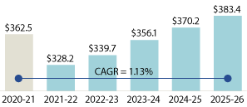
Price path 2020-21 to 2025-26  (all prices shown in $/ML terms) | 2020-21 | 2021-22 | 2022-23 | 2023-24 | 2024-25 | 2025-26
1.1 Bulk water charge - Greater Yarra System | $362.5 | $328.2 | $339.7 | $356.1 | $370.2 | $383.4
Compound annual growth rate = 1.13%
Percentage water revenue = 26.4%
1.2 Bulk water headworks charges – Victorian Desalination Plant
This is a pass through tariff applied to entitlement ML’s. The amount passed through is adjusted downward by the amount Melbourne Water capitalises.
Entitlements:
City West Water: 39,595 ML
South East Water: 53,454 ML
Yarra Valley Water: 56,951 ML
Western Water: No current entitlement
Barwon Water: No current entitlement
South Gippsland Water: No current entitlement
Westernport Water: No current entitlement
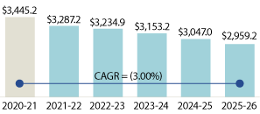
Price path 2020-21 to 2025-26  (all prices shown in $/ML terms) | 2020-21 | 2021-22 | 2022-23 | 2023-24 | 2024-25 | 2025-26
1.2 Bulk water headworks charge - Victorian Desalination Plant | $3,445.2 | $3,287.2 | $3,234.9 | $3,153.2 | $3,047.0 | $2,959.2
Compound annual growth rate = 3.00%
Percentage water revenue = 54.2%
1.3 Victorian Desalination Plant Water Order charge
This is a pass through tariff applied to the ML ordered linked to entitlements.
Entitlements:
City West Water: Charges based on order volume and fee schedule
South East Water: Charges based on order volume and fee schedule
Yarra Valley Water: Charges based on order volume and fee schedule
Western Water: No current entitlement
Barwon Water: No current entitlement
South Gippsland Water: No current entitlement
Westernport Water: No current entitlement
Fee schedule (not reproduced here) is provided by Department of Environment, Land, Water and Planning and includes a price path for each available order size. Water order prices may change throughout the regulatory period.
1.4 Bulk water headworks charges – North South Pipeline
This tariff is based on regulatory building blocks applied to entitlement ML’s.
Entitlements:
City West Water: 25,000 ML
South East Water: 25,000 ML
Yarra Valley Water: 25,000 ML
Western Water: No current entitlement
Barwon Water: No current entitlement
South Gippsland Water: No current entitlement
Westernport Water: No current entitlement
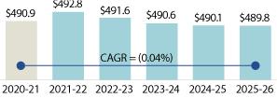
Price path 2020-21 to 2025-26  (all prices shown in $/ML terms) | 2020-21 | 2021-22 | 2022-23 | 2023-24 | 2024-25 | 2025-26
1.3 Bulk water headworks charges – North South Pipeline | $490.9 | $492.8 | $491.6 | $490.6 | $490.1 | $489.8
Compound annual growth rate = 0.04%
Percentage water revenue = 4.3%
1.5 Bulk water usage charges –Transfer
This tariff is based on regulatory building blocks applied to supplied ML’s
Entitlements:
City West Water: 115,725 ML
South East Water: 164,028 ML
Yarra Valley Water: 167,000 ML
Western Water: 14,367 ML
Barwon Water: 1,100 ML
South Gippsland Water: 800 ML
Westernport Water: 600 ML
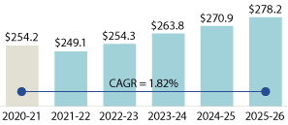
Price path 2020-21 to 2025-26  (all prices shown in $/ML terms) | 2020-21 | 2021-22 | 2022-23 | 2023-24 | 2024-25 | 2025-26
1.5 Bulk water usage charges – Transfer | $254.2 | $249.1 | $254.3 | $263.8 | $270.9 | $278.2
Compound annual growth rate = 1.82%
Percentage water revenue = 15.1%
Table 9 - Overview of proposed bulk sewerage prices
1.7 Bulk sewerage usage charge – Treatment ($/ML)
Based on long-run marginal cost calculations.
System  Treated volume (ML) – 2021-22 forecasts shown for context | City West Water | South East Water | Yarra Valley Water
Eastern | Not applicable | 81,619 | 48,052
Western | 90,391 | 26,906 | 78,481
Price path 2020-21 to 2025-26
System  Treated volume (ML) – 2021-22 forecasts shown for context | Price Submission 2016 ($/ML) | Price Submission 2021 ($/ML) | Percentage Change
Eastern | $78.8 | $50.8 | (35.5%)
Western | $293.3 | $74.1 | (74.7%)
Percentage Sewerage Revenue = 4.5%
1.8 Bulk sewerage usage charge – Transfer ($/ML)
Based on short-run marginal cost calculations.
System  Transferred volume (ML) – 2021-22 forecasts shown for context | City West Water | South East Water | Yarra Valley Water
Eastern | Not applicable | 81,619 | 48,052
Western | 90,391 | 29,906 | 78,481
Price path 2020-21 to 2025-26
System  Transferred volume (ML) – 2021-22 forecasts shown for context | Price Submission 2016 ($/ML) | Price Submission 2021 ($/ML) | Percentage Change
Eastern | $5.7 | $5.6 | (2.7%)
Western | $40.1 | $39.1 | (2.7%)
Percentage Sewerage Revenue = 1.7%
1.9 Bulk sewerage usage charge – Load ($/per tonne)
Based on long-run marginal cost calculations (with the exception of iTDS)
System  These charges apply to measured industrial and commercial loads. 2021-22 forecasts for Category A non-residential customers shown for context. | City West Water | South East Water | Yarra Valley Water
Eastern: TSS | Not applicable | 3,178 | 582
Eastern: BOD | Not applicable | 8,176 | 1496
Eastern: TKN | Not applicable | 396 | 34
Western: TSS | 3,426 | 183 | 3,601
Western: BOD | 11,642 | 1,421 | 9,370
Western: TKN | 996 | 48 | 267
Western: iTDS | 27,731 | 227 | 7538
Price path 2020-21 to 2025-26
System  These charges apply to measured industrial and commercial loads. 2021-22 forecasts for Category A non-residential customers shown for context. | Price Submission 2016  ($/tonne) | Price Submission 2021 ($/tonne) | Percentage Change
Eastern: TSS | $603.7 | $733.4 | 21.%
Eastern: BOD | $367.7 | $318.9 | (13.3%)
Eastern: TKN | $210.3 | $95.5 | (54.6%)
Western: TSS | $113.4 | $670.9 | 491.6%
Western: BOD | $195.2 | $398.6 | 104.2%
Western: TKN | $269.6 | $1,364.3 | 406.1%
Western: iTDS | $32.0 | $32.0 | 0%
Percentage Sewerage Revenue = 4.5%
1.10 Bulk sewerage service charge – ($/per month)
Calculated using cost allocation percentages (below) applied to total sewerage revenue requirement less calculated variable charges (above)
System  Bulk sewerage service charge | City West  Water | South East Water | Yarra Valley Water
Total | 23.1%  22.6% in Price Submission 2016 | 39.0%  40.4% in Price Submission 2016 | 37.9%  37.0% in Price Submission 2016
Eastern | Not applicable | 86.3%  87.0% in Price Submission 2016 | 55.4%  61.5% in Price Submission 2016
Western | 100%  10% in Price Submission 2016 | 13.7%  13.0% in Price Submission 2016 | 44.6%  38.5% in Price Submission 2016
Price path 2020-21 to 2025-26
System | City West  Water | South East Water | Yarra Valley Water
Approved | $5.7 million | $13.3 million | $11.4 million
Forecast 2021-22 | $7.4 million | $13.8 million | $13.0 million
Forecast 2022-23 | $7.6 million | $14.2 million | $13.4 million
Forecast 2023-24 | $7.9 million | $14.7 million | $13.9 million
Forecast 2024-25 | $8.2 million | $15.7 million | $14.4 million
Forecast 2025-26 | $8.6 million | $15.9 million | $15.1 million
Percentage Sewerage Revenue = 89.3%

PREMO assessment
Reflecting our ambition for this price submission and for our customers, we have pushed ourselves harder than ever before so that we could deliver a high-quality proposal that puts the needs of customers first.
We believe we have achieved this and prepared a submission that aligns with the Essential Services Commission’s “advanced” level of ambition as shown on Figure 7. KPMG has independently assessed the submission as “advanced”. Our rating of each element, and our rationale for the element rating is described below.

PREMO – Risk
We have assessed our ambition against the “Risk” element of PREMO and have assigned an advanced rating. Our Board and Leadership Team challenged themselves to take a critical look at the way we balance risk between ourselves and our customers. The result is a more active and critical consideration of uncertainty and the way it impacts our revenue building blocks. The key features of our approach and offer that support this rating include:
- Risks relating to the operations and management of our business, and how those risks impact customers, were comprehensively identified and evaluated with clarity provided around the nature, management and quantification of each risk.
- We demonstrate throughout our submission (and supplement) both the process and the end result of our near 30-month journey to ensure all parts of the organisation give clear consideration to the assumptions that underpin our key proposals, and that we effectively and fairly allocate risk between Melbourne Water and customers.
- Melbourne Water has consciously accepted more risk via opex forecasts which reduce the amount of uncertainty we are asking customers to fund. This includes Melbourne Water bearing the risk of non-delivery or downtime associated with our large renewable energy self-generation forecast.
- We have elected to “smooth” the capital program. We have taken this decision to acknowledge that there is increased delivery risk associated with our larger capital program (compared to Price Submission 2016) and that this may be exacerbated by COVID-19 in the near term. The effect of this decision is to “push” $271.3 million from years one and two, into years three ($9.3 million), four ($45.3 million) and five ($216.6 million) – reducing our aggregate revenue requirement by $42.9 million.
- We have also accepted more risk on behalf of customers in the base capital program, deferring (via strong internal discipline) $498 million in capital projects which equates to customer savings of $85.8 million over the regulatory period.
- We have completed a robust consideration of COVID-19-related risks to the price submission and detailed our responses, including proactively adjusting the timing of the proposed waterways and drainage charge uplift. We also propose to bear the revenue risk associated with lower-than-forecast levels of demand.
- Our proposed performance management approach (including the introduction of guaranteed service levels for the first time) emphasises transparency in relation to performance and our possible responses to underperformance, which may include consideration of additional funding and/or consideration of appropriate repayments to customers (for example, chronic underperformance).
- We are proposing pass-through and uncertain and unforeseen events mechanisms for highly uncertain or significant events such as water order placement, pumping costs associated with water orders and any future augmentation of the Victorian Desalination Plant, rather than building these costs into our regulated revenue allowance.
- Melbourne Water regularly has its financial position reviewed by independent credit ratings agencies. We remain confident that we are in a sound financial position.
Figure 7 - An “advanced” submission
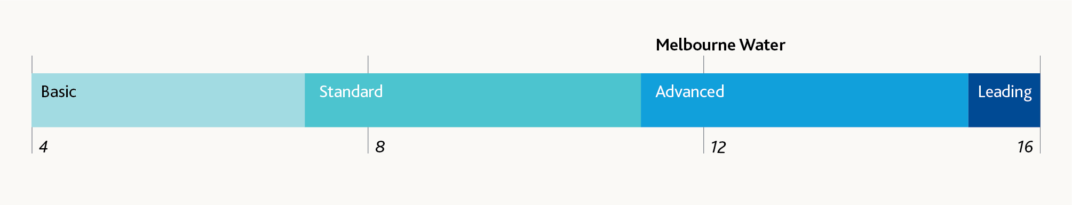
PREMO rating | Score
No rank | 4
Basic | 7.25
Standard | 11.25
Advanced | 15.25
Leading | 16

PREMO – Engagement
We have assessed our ambition against the “Engagement” element of PREMO and have assigned an advanced rating. The key features of our approach and offer that support this rating include:
- We were consciously customer-centric in the way we delivered our price submission. We moved to a deeper engagement form (towards collaboration), with broader content (towards performance stewardship) and earlier timing (towards an ongoing conversation). Our engagement program was purposeful about matching the engagement aims and approaches to PREMO and our customers’ expectations.
- Our extensive and detailed customer and community engagement program engaged retail water companies (six), households and businesses (145+ participants in 20 focus groups and one online panel; 3,753 household residents and 535 businesses responded to two surveys testing investment preferences), and local government, industry associations and community groups.
- We enabled effective collaboration through the provision of timely, fit-for-purpose instruction and information. The Water and Sewerage Customer Council acknowledged the “genuine effort by Melbourne Water to engage the council during this process and commends their efforts”.
- We provided opportunities throughout our engagement process for our customers and customer councils to tell us if we were falling short of expectations, and we listened and responded, acting to meet expectations where we could, and setting out our reasoning where we could not.
- Our price submission demonstrates a high level of customer influence on our proposals – from our household and business, and retail water company customer segments, with customer preferences supporting or encouraging an uplift in key waterways and drainage services, a significant change to the way in which we capitalise Victorian Desalination Plant payments, the introduction of guaranteed service levels and a comprehensive tariff structure review commitment.
- There is a clear and strong alignment between our proposals and customer preferences that is particularly evident in our customer outcomes.

PREMO – Management
We have assessed our ambition against the “Management” element of PREMO and have assigned an advanced rating. Key features of our approach and offer that support this rating include:
- Our Board and Leadership Team have demonstrated ownership of, and commitment to, the submission and its outcomes via their guidance, review and challenge over the past 30 months. Our Managing Director chaired a Price Submission 2021 steering committee comprising the Chief Financial Officer and general managers of Customer and Strategy, Service Delivery and Integrated Planning to oversee the development of the submission.
- Robust review and challenge sessions have enabled us to:
  - defer $498 million in capital projects with a strong case for inclusion on prudency grounds
  - keep our base opex flat while supporting a growing population – based on forecast population growth of 1.95 per cent per annum, this represents a 2 per cent per annum efficiency outcome.
- We propose to capitalise a total of $399 million of Victorian Desalination Plant security payments (water service only) – an increase of $235 million compared to Price Submission 2016 – to deliver a more equitable customer share of the asset costs over the life of the asset. This decision benefits our current customers by reducing our Price Submission 2021 revenue requirement by $217 million.
- We propose a dedicated output (associated with the “Bills kept as low as possible” outcome) that firmly commits us to new efficiencies, on top of those already embedded within our opex forecast (to be realised in either the coming or subsequent regulatory period).
- We also commit to increasing the transparency we apply to our expenditure within regulatory periods by publishing annual updates of opex and regulatory asset base closing balance – to be presented on a per-connected-property basis.
- We continue to drive material capital efficiencies in the way in which we deliver our capital program. During Price Submission 2016 we have introduced major framework agreements delivering in the order of a quarter of the total program (annually). Incentive-based clauses in the agreements are delivering savings in the order of $6.5 million per annum (assuming a $200 million annual program through the framework agreements). Over the course of Price Submission 2021 these agreements will continue to drive improvements, including delivering greater self-performance of works, reducing the reliance on (and cost of) subcontractors.
- We engaged experienced and highly skilled consultants to assist in the development of our submission and provide assurance about the quality of the submission, including the quality of supporting information relating to forecast costs or projects:
  - Newgate Australia and Whereto to help design and deliver an industry-leading customer and community engagement process
  - KPMG to help guide and review the submission to ensure that the information requirements in the Essential Services Commission's Guidance Paper were met
  - KPMG to ensure that our business case information supports the proposed capital expenditure for major capital projects.
- We implemented a rigorous assurance process to ensure the credibility, accuracy and consistency of our submission and supporting information, involving both internal (internal audit, submission project team) and external (KPMG) review elements.
- Cumulatively the management (and risk) decisions we have taken deliver a $303.1 million (real) reduction in our overall revenue requirement compared to the Price Submission 2016 determination, while supporting a growing population.

PREMO – Outcomes
We have assessed our ambition against the “Outcomes” element of PREMO and have assigned an advanced rating. The key features of our approach and offer that support this rating include:
- Our focus is on what our customers tell us they value. This is reflected in expenditure that aligns clearly with our outcomes and the relative priority our customers have assigned each outcome. By way of example, 32.3 per cent of our expenditure forecast for Price Submission 2021 aligns with “access to safe and reliable water and sewerage services” – the unanimous number one priority for our retail water company and household and business customers.
- We are increasing customer value in both water and sewerage, and waterways and drainage services, by providing greater public access to assets we need to deliver our core services, and increasing our waterways and drainage investment in line with expressed customer priorities and willingness to pay.
- We are proposing a more transparent and ambitious approach to the way in which we deliver our services, reflected in a commitment to materially improve baseline customer satisfaction scores across each of our major service lines (water, sewage, waterways and drainage) – corresponding to “easy, respectful, responsive and transparent customer service”.
- Our customer outcomes are articulated from the customer perspective.
- Across each of the other outcomes we are proposing first time measures, reflecting a new level of accountability for Melbourne Water in the delivery of our services. This includes putting ourselves in the hands of our customers to demonstrate we have achieved community benefits for our liveability outcome.
- We are holding ourselves accountable via the introduction of guaranteed service levels for the first time, and a commitment to a customer-centric performance management approach that will emphasise transparency in relation to performance and our possible responses to underperformance.
- We will report directly, via a representative customer forum, and broadly, via our website and social media channels.

Attachment 1: COVID-19 considerations
Our COVID-19 engagement activities are detailed in this section along with adjusted demand forecasts used to develop modelling outputs and assumptions to draw insights on our expenditure forecasts.

Additional engagement activities
As part of our response to the COVID-19 pandemic we added an additional stage to our engagement program. Noting that the final stage of our engagement program ran concurrently with the emergence of the pandemic and the first stage of social restrictions, this additional consultation sought to test and refine draft proposals on how we might ease bill impacts in the community in the immediate (year one) and medium term across the regulatory period.

Household, business and direct service customers
We engaged with household and business customers via a representative customer panel (the same panel we used for customer outcomes engagement), and with direct services customers where a service/price increase is proposed. We also advised consumer advocate groups, Department of Environment, Land, Water and Planning and our Water and Sewerage Customer Council of the proposals.

Matters we consulted on
Participants in the Community Deliberative Forum were reminded where we had landed with our final six customer outcomes, prices and service levels. We then asked the panel to deliberate on three proposals we might consider to “keep bills as low as possible”, including price smoothing, hardship assistance and related initiatives, and price reductions accompanied by, or following, expenditure pauses/deferrals.
For Patterson Lakes Quiet Lakes and the Koo Wee Rup–Longwarry Flood Protection District direct service customers, we proposed to delay the price increase and associated increase in service level for 2021-22 (continue with current levels of service and charge), with the intention to revisit our approach in 2022-23, subject to further community engagement at that time.
Table 10 summarises the customers we engaged through this additional stage of consultation, the methods used and the key insights we gained.
We also engaged with customer advocacy bodies such as the Consumer Action Law Centre (CALC) to gain a further independent perspective on our proposals. The Consumer Action Law Centre supported the proposals and provided a range of other suggestions including a boost to the utility relief grant, ensuring we capitalise as much of the security payments for the desalination plant as possible, and ensuring the lowest possible setting of the cost of capital. No other feedback was received from the other consumer groups we reached out to.

Retail water companies
Retail water companies were engaged to understand their preferences in terms of appropriate management responses to any COVID-19-adjusted growth forecasts and the revenue and cost risks that adjusted demand forecasts entail.
Retail water companies were strongly of the view that Melbourne Water should seek to minimise any upward price pressures arising from COVID-19. Where possible their preference was for Melbourne Water to accept higher revenue risk, rather than pass that risk on to customers via revised demand forecasts and higher prices.
Table 10 - Summary of COVID-19 specific engagement activities and insights
Who | Form of engagement | Key insights
Household and business customers | - Community Deliberative Forum – a representative sample of 39 people from across Melbourne participated via an online forum over four days (10-13 September 2020).  - Same participants who deliberated on our final customer outcomes to ensure continuity through the final engagement stages. | - 74 per cent of participants had been negatively financially impacted or expected to be financially impacted by COVID-19 in the coming months.  - 59 per cent were concerned or very concerned about paying their bills and believe they will struggle to pay their bills because of COVID impacts, while 41 per cent were not concerned at all about their ability to manage their bills because of COVID-19.  - Reinforced support for our six customer outcomes, despite the financial impacts of COVID-19, with slightly more emphasis on Outcome 6 (“bills kept as low as possible”).  - Confirmed the acceptability of our proposed price changes.  - Endorsed proposal for smoothing of waterways and drainage charge price increases across five years rather than a single year one uplift.  - Endorsed proposal to identify opportunities to work with the retail water companies to assist in looking after vulnerable customers.  - Endorsed proposal to collaborate with ongoing customer forum to monitor customer affordability metrics which may lead to a pause, deferral of projects and/or one-off or multi-year reduction of charges for larger-scale interruptions to project delivery.  “I’m really pleased to hear that Melburne Water is considering the serious impacts that COVID-19 has had on customers and the community. Almost all businesses have had to adapt and will feel the pain of COVID so I would expect MW to do the same. The thing that stood out the most was the consideration of what the customer has been saying and listening. I'm pleased with that.”
Patterson Lakes Quiet Lakes community | - Telephone survey of 30 randomly selected residents, representing a sample of around 12 per cent of the 251 affected properties affected. | - Of the 30 properties surveyed, the majority (24 participants) did not support the proposed delay of the service/price increase and wanted it to go ahead irrespective of COVID-19 (3 supported the proposed delay and 3 did not know/didn’t have a view). This view was also held by the president of the Residents Association.  - A majority of respondents (20) were not concerned about the financial impacts of COVID-19 and had not been personally financially impacted, with no concerns about paying their bills (23).
Koo Wee Rup–Longwarry Flood Protection District | - District Advisory Committee members and property owners contacted via email to outline proposed approach and invite feedback.  - Responses received from 24 people, representing a very small proportion of about 0.65 per cent of the approximately 3,700 affected properties (a similar response rate to previous surveying of this community). | - Of the 24 people who responded to the email, 18 people supported the proposed delay (4 did not support the delay and 1 did not know).  - A majority of respondents (18) were very concerned about the financial impacts of COVID-19, and about a third (8) were personally financially impacted. A little over half were either very concerned (6) or slightly concerned (7) about being able to pay their bills.

Additional demand analysis
We also added an additional stage to our demand analysis that included engagement of Macroplan, a property advisory consultancy with a strong research, economics and forecasting capability to prepare a COVID-19-adjusted growth outlook for Melbourne. Their brief included provision of a comparison to the Victoria in Future 2019 forecasts, which underpin the detailed bottom-up forecasts prepared by retail water companies and BIS Oxford Economics for our waterways and drainage, water and sewage demand forecasts.
Table 11 shows the Macroplan forecasts and compares them to Victoria in Future 2019 from a 2019-20 base year. Note that the two series are only 477 persons apart from their starting year of 2018-19.
It shows that Macroplan is forecasting growth across the 2019-20 to 2020-21 period will be less than half of the Victoria in Future 2019 growth projection for the same period. Over the six-year period modelled Macroplan’s annualised growth rate is 0.22 percentage points lower than Victoria in Future 2019, largely as a result of this first year of lower growth.
The bottom half of Table 11 provides a worked example of how we have used Macroplan’s forecasts to model a lower growth forecast. We have applied the same methodology to waterways and drainage and water forecasts to deliver the scenario analysis presented below.
Table 11 - Comparison of Victoria in Future 2019 and independent COVID-19 adjusted population forecasts
Item | 2019-20 | 2020-21 | 2021-22 | 2022-23 | 2023-24 | 2024-25 | 2025-26 | Compound Annual Growth Rate (refer Note )
Victoria in Future 2019 (Melbourne) | 5,193,281 | 5,306,133 | 5,416,527 | 5,525,539 | 5,632,346 | 5,737,980 | 5,843,344 | 1.99%
Percentage change year-on-year | refer  Note | 2.17% | 2.08% | 2.01% | 1.93% | 1.88% | 1.84% | N/A
Percentage change from 2019-20  base (A) | N/A | 2.17% | 4.30% | 6.40% | 8.45% | 10.49% | 12.52% | N/A
Macroplan | 5,169,680 | 5,219,990 | 5,325,880 | 5,431,021 | 5,535,868 | 5,639,754 | 5,742,578 | 1.77%
Percentage change year-on-year | refer  Note | 0.97% | 2.03% | 1.97% | 1.93% | 1.88% | 1.82% | N/A
Percentage change from 2019-20  base (B) | N/A | 0.97% | 3.02% | 5.06% | 7.08% | 9.09% | 11.08% | N/A
Absolute difference | (23,601) | (86,143) | (90,647) | (94,518) | (96,478) | (98,226) | (100,766) | N/A
Adjustment factor (C) = (B) / (A) | N/A | 44.8% | 70.3% | 79.0% | 83.8% | 86.7% | 88.5% | N/A
Worked example – how we have applied the Macroplan COVID-19-adjusted growth forecasts for modelling purposes:
Item | 2019-20 | 2020-21 | 2021-22 | 2022-23 | 2023-24 | 2024-25 | 2025-26 | Compound Annual Growth Rate (refer Note )
Base sewage forecast (D) | 320,738 | 322,537 | 325,449 | 328,361 | 331,092 | 333,741 | 336,339 | 0.79%
Base growth year on year (E) | N/A | 1,800 | 4,712 | 7,624 | 10,355 | 13,003 | 15,602 | N/A
Adjusted growth  (F) = (E) x (C) | N/A | 806 | 3,312 | 6,024 | 8,675 | 11,273 | 13,813 | N/A
Adjusted sewage forecast  (G) = (D) – (E) + (F) | 320,738 | 321,543 | 324,049 | 326,761 | 329,412 | 332,011 | 334,550 | 0.71%
Note A: Compound annual growth rate values are shown from the period from 2019-20 to 2025-26. Note that these values are 1.95% and 1.93% respectively when 2020-21 is used as a base year, consistent with the analysis presented in later sections.
Note B: Percentage changes for this year are not shown. Melbourne Water has actual demand data for this year. For the purposes of the analysis we have only considered the relative difference between Victoria in Future 2019 and Macroplan from this year onwards.

Consideration of expenditure implications of demand analysis
The following analysis considers potential changes to our expenditure forecasts under Macroplan’s COVID-19-adjusted growth outlook. Note that commentary and analysis conservatively considered much more significant slow-downs in growth.
In terms of capex, this is relevant to the projects with a growth driver. This includes both forecast growth, but also the strong growth in population that has occurred throughout the current regulatory period.
For opex, this primarily manifests in consumable expenditures such as chemicals and energy, but is also linked to the number and nature of growth-driven assets we propose to build and maintain.

Capex
Figure 8 highlights the aggregate capital that is funded by our customers. It also shows the split between growth and other (renewals, improvements and compliance) drivers.
COVID-19 risks to the growth driver for major projects are addressed in Table 12, Table 13, and Table 14.
Commentary presented in these tables is based on consideration of reduced growth forecast scenarios, where growth is assumed to be flat for up to two years (2020-21 to 2022-23) or throughout the Price Submission 2021 regulatory period (from 2020-21 to 2025-26). The consistent theme in our commentary is that our projects with a “growth” driver are needed now (within Price Submission 2021) in order to address recent rather than forecast growth and prudently manage service (to customers and the environment), financial and operational risks.

Capital delivery risk
This submission outlines an uplift in our capital program to respond and align with customer preferences, and tackle a number of key challenges. Prolonged restrictions to construction activity (should they eventuate) would represent a risk to the delivery of the capital program.
Figure 8 - Capex breakdown – highlighting growth capex by major service
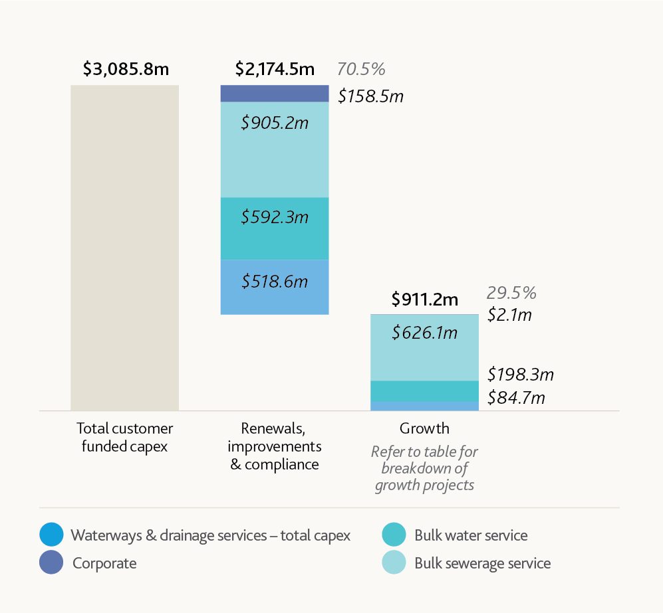
Item | Base | Waterways and drainage services - total capex | Bulk water service | Bulk sewerage service | Corporate | Total | %
Total customer funded capex | $0.0m | N/A | N/A | N/A | N/A | $3,085.8m | N/A
Renewals, improvements and compliance | $911.2m | $518.6m | $592.3m | $905.2m | $158.5m | $2,174.5m | 70.5%
Growth | $0.0m | $84.7m | $198.3m | $626.1m | $2.1m | $911.2m | 29.5%
Table 12 - COVID-19 risks to prudency of major growth projects – waterways and drainage
Project – growth driver | Price Submission 2021 capex | % growth capex by service | Commentary
Land development (net) | $84.7m | 100% | The net land development program expenditure is a function of forecast capital expenditure ($701.2 million) and developer services revenue ($616.5 million – capital component only).  From a waterways and drainage charge perspective our customers fund the net position with the developer services revenue taken off our regulated asset base (RAB), reducing the amount of growth capex that customers fund via the waterways and drainage charge to $84.7 million.  Melbourne Water bears the bulk of any downside growth risk for this category. While developers may be able to defer their developments (and payments to us) we typically have less scope for deferral as we are supporting recent or immediate land development activity.
Total | $84.7m | 100% | N/A
Table 13 - COVID-19 risks to prudency of major growth projects – water
Project – growth driver | Price Submission 2021 capex | % growth capex by service | Commentary
Yan Yean to Bald Hill Pipeline | $95.7m | 48% | Required now as the current transfer system to Bald Hill area is under sized. This system is considered high risk due to single supply (that is it has no redundancy). The primary driver is the location of recent growth, rather than forecast growth.
Mt Atkinson Reservoir Inlet Pipeline | $31.5m | 16% | Required now as it is needed to provide a physical connection to that area. The primary driver is the location of recent growth, rather than forecast growth.
Cement Creek Diversion Works | $27.6m | 14% | While allocated a “growth” driver, the Cement Creek Diversion Works project is primarily driven by a retail water company-supported desire to address long-term water security (in 2019 water storages dropped below 50 per cent of capacity).
Yan Yean Pumping Station | $21.1m | 11% | Required under low growth scenarios as it provides material efficiencies via the potential to operate with less pumps/different operating sequence.
Mt Atkinson Service Reservoir | $11.8m | 6% | Required now as it is needed to provide a physical connection to that area. The primary driver is the location of recent growth, rather than forecast growth.
Other | $10.7m | 5% | Inclusive of the following projects:  Bald Hill Service Reservoir: Transfer system is currently reaching its limit and the service reservoir would still be required under all reduced growth scenarios.  Preston Pump Station Surge Mitigation: Project could be delayed; however, other operational issues may reduce capacity to defer these works beyond a few years. For system resilience, this should be built in the next 12 months.
Total | $198.3m  (refer Note a) | 100% | N/A
Note a: Numbers do not add due to rounding
Table 14 - COVID-19 risks to prudency of major growth projects – sewerage
Project – growth driver | Price Submission 2021 capex | % growth capex by service | Commentary
Western Treatment Plant Primary Treatment Capacity Augmentation | $315.3m | 50% | The Western Treatment Plant anaerobic pots combine primary treatment and anaerobic digestion, converting chemical oxygen demand (COD) to biogas for renewable power generation.  COD loading to the anaerobic pots is currently well in excess of the sustainable treatment capacity (~450 tonnes per day).  This project is needed at this time to reduce high-frequency and high-cost cover removal and replacement (due to lost capacity from accumulated sludge and damage by accumulated scum) activities. It will also reduce Western Treatment Plant opex as the current poor process performance shifts COD load to the downstream secondary treatment process where it requires increased aeration, which increases energy costs.  On this basis the need for this project is considered immediate.
Western Treatment Plant 55E ASP Upgrade | $211.4m | 34% | The Western Treatment Plant’s three activated sludge plants (ASPs) remove nitrogen.  The Western Treatment Plant has breached the total nitrogen discharge load limit set out in the Port Phillip Bay Environmental Management Plan for the past two financial years. This is due to demand exceeding nitrogen removal capacity for a number of successive years.  Future demand growth will exacerbate this disparity.  Delivering the project as scheduled provides a time-limited opportunity to realise circa $40 million in savings, by temporarily shutting down the existing 55E ASP during the upgrade so that its existing clarifiers can be reused by the new plant. This opportunity and the associated saving would be foregone should the project be deferred.  Based on recent and forecast capacity exceedances, and the opportunity for significant capital cost savings, the risk of project delay are considered to outweigh the risk of zero demand growth for the scenarios considered.
Eastern Treatment Plant Digester Auxiliary Systems Upgrade | $30.2m | 5% | The Eastern Treatment Plant anaerobic sludge digestion system is currently at capacity and requires augmentation. This upgrade to digester auxiliary systems represents Stage 2 of a multi-staged approach to addressing this capacity constraint. Stage 1 of the project is underway with a design and construct contract awarded in November 2019.  Only under a zero growth until 2025-26 scenario could a delay be considered; however, this would come with the following risks:  - materially higher aeration energy consumption and Scope 2 emissions generation  - materially higher risk of process failure, with consequent service and financial risks (months-long odour incident impacting general public and likely financial penalty (EPA sanction).  Under the COVID-19 adjusted growth outlook provided by Macroplan this project would be required as planned. There is no potential for delay.
Western Treatment Plant 125W Sludge Drying Pans | $16.8m | 3% | There are currently 130,000 dry tonnes of solids accumulated in the Western Treatment Plant lagoons, impacting treatment process performance and capacity. This project provides additional capacity required to remove these solids. Consequently a cessation in raw sewage flow/load growth (two years or to the end of Price Submission 2021) would not change project timing.  Construction contract awarded first quarter 2020-21.
Eastern Treatment Plant Sludge Drying Capacity Augmentation | $15.7m | 3% | An upgrade to the Eastern Treatment Plant’s sludge drying capacity is needed to cater for growth as the existing sludge drying pans (SDPs) are at capacity. Melbourne Water has developed a concept for a large-scale drying facility ($121.1 million); however, it has deferred most of this cost into the following regulatory period, on the assumption that some additional drying capacity can be provided at lower cost by optimising the existing SDPs (funded from the $15.7 million allowance retained in Price Submission 2021).  Deferring these optimisation works would impose a capacity risk, particularly as pan performance is highly weather-dependent, with wet years (such as 2019-20) significantly reducing sludge drying capacity.
Eastern Treatment Plant Biogas Handling System Upgrade | $14.5m | 2% | Key elements of the biogas handling system (compressors and waste gas burners) are capacity constrained at current raw sewage loads. Consequently, a cessation in raw sewage flow/load growth (two years or to the end of Price Submission 2021) would not change project timing.
Other | $22.3m | 4% | The “other” category comprises three Eastern Treatment Plant projects scheduled for completion in the first three years of the regulatory period and circa $0.6 million in corporate allocations.
Total | $626.1  (refer Note a) | 100% | N/A
Note a: Numbers do not add due to rounding

Opex
Key factors relevant to COVID-19 risks to our opex forecasts include:
- Our opex forecasts have a proportional link to volumetric and load-based demand through the chemicals and energy required to treat and move the water consumed and sewage generated by our customers. It is important to note that operational decisions to manage water security (such as the recommissioning of the Yan Yean treatment plant) have a far greater impact on both chemicals and energy growth than the forecast growth in megalitres of water supplied or sewage treated.
- The reduction in the forecast growth rate from 1.95 to 1.93 per cent represents about $1 million variance to the 2 per cent efficiency target over the five-year regulatory period.
- For the majority of other expenditure categories, the link to volumetric and load-based demand is less direct, with the size and nature of our asset base far more predictive.
- Applying the demand adjustment methodology outlined above we developed COVID-19-adjusted forecasts for energy and chemicals for the water and sewerage services shown in Table 15.

Scenario analysis – alternative growth outlooks
Having finalised our original demand forecasts during the first half of 2020 – when the COVID-19 pandemic was in its early stages – we considered two management responses to Macroplan’s COVID-19-adjusted forecasts for the purposes of this submission:
Scenario 1 – Assumes the acceptance of the COVID-19-adjusted demands (and expenditures) as our revised “best estimates”). Under this scenario demand forecasts are adjusted for COVID-19, with actual demand in line with adjusted forecasts.
Scenario 2 – Assumes the retention of pre-COVID-19 demands (“original” estimates of demand and expenditure). Under this scenario demand forecasts are unadjusted for COVID-19, with actual demand (that is post submission) lower than submission forecasts and in line with the Macroplan forecasts.

Modelling results
The scenarios we considered to finalise our demand and expenditure forecasts are shown in Table 16 and Table 17, taking into account the engagement, demand and expenditure analysis outlined in the preceding sections.
Table 16 shows that adopting the COVID-19-adjusted demand forecasts (Scenario 1) for our waterways and drainage service would reduce Melbourne Water’s revenue risk profile by $16.2 million, compared to Scenario 2. This is achieved by increasing customer prices by $1.3 per customer for residential customers, $1.90 per customer for non-residential customers (on minimum) and $0.70 per customer for rural customers.
Table 17 shows that adopting the COVID-19-adjusted demand forecasts (Scenario 1) for our water and sewerage service would reduce Melbourne Water’s revenue risk profile by a further $0.4 million, compared to Scenario 2.
Table 15 - COVID-19 opex adjustments to chemicals and energy categories
Item | Base/Adjustment | Water | Sewerage | Total
Chemicals | Base | $34.6m | $16.7m | $51.3m
Chemicals | Adjusted | $34.4m | $16.6m | $510m
Chemicals | Adjustment | ($0.2m) | ($0.1m) | ($0.3m)
Energy (contract) | Base | $34.2m | $158.7m | $192.9m
Energy (contract) | Adjusted | $34.0m | $157.9m | $191.9m
Energy (contract) | Adjustment | ($0.2m) | ($0.8m) | ($1.0m)
Total | Adjustment | ($0.4m) | (0.9m) | ($1.3m)
Table 16 - Implications of COVID-19 adjusted growth outlook – waterways and drainage charge
Submission forecasts
Element | Average/Aggregate | Scenario 1 | Scenario 2 | Change comparison Scenario 2 to Scenario 1
Expenditure | N/A | Unchanged across scenarios modelled | Unchanged across scenarios modelled | Unchanged across scenarios modelled
Revenue requirement | Aggregate | $1,429.3m | N/A | $0m
From waterways and drainage charge | Aggregate | $1,360.1m | N/A | $0m
From other sources | Aggregate | $69.2m (not included in analysis below) | N/A | $0m
Waterways and drainage charge customers | N/A | N/A | N/A | N/A
Residential | Average | 2,066,572 | 2,093,268 | +30,541
Non-residential on minimum | Average | 149,330 | 151,060 | +1,934
Rural | Average | 117,841 | 119,363 | +1,741
Total | Average | 2,333,743 | 2,363,691 | +34,216
Price | N/A | N/A | N/A | N/A
Residential | Average | $108.8 | $107.5 | ($1.3)
Non-residential on minimum | Average | $163.4 | $161.5 | ($1.9)
Rural | Average | $59.7 | $59.0 | ($0.7)
Post submission actuals  (scenarios 1 and 2 assume COVID-19 adjusted forecasts become actuals) | N/A | N/A | N/A | N/A
Actual total (average) customers | Average | 2,333,743 | 2,333,743 | Nil
Revenue earned – waterways and drainage charge | Aggregate | $1,360.1m | $1,343.9m | ($16.2m)
Net position – Scenario 2 compared to Scenario 1 | N/A | N/A | N/A | N/A
Melbourne Water | Aggregate | N/A | ($16.2m) | N/A
Customers (aggregate cumulative)  (refer Note a) | Aggregate | N/A | +$14.9m  (refer Note a) | N/A
Note a: Aggregate annual customer benefit is calculated by multiplying the average price difference (per customer type) by the average number of actual customers. The final aggregate cumulative amount takes the aggregate annual amount and multiplies it by the five years of the regulatory period. The difference in benefit compared to Melbourne Water’s position goes to customers who do not become customers over the period.
Table 17 - Implications of COVID-19 adjusted growth outlook – water and sewerage services
Water service
Element | Average/Aggregate | Scenario 1 | Scenario 2 | Change comparison Scenario 2 to Scenario 1
Submission forecasts | N/A | N/A | N/A | N/A
Demand | N/A | N/A | N/A | N/A
Forecast water supplied (ML) | Average | 469,215 | 471,798 | +2,583
Expenditure | N/A | N/A | N/A | N/A
Controllable opex | Aggregate | $473.2m | $473.6m | +$0.4m
Capex | Aggregate | Unchanged across scenarios | Unchanged across scenarios | Unchanged across scenarios
Revenue requirement | N/A | N/A | N/A | N/A
Revenue requirement – variable charge | Aggregate | $620.7m | $621.1m | +$0.4m
Prices | N/A | N/A | N/A | N/A
Variable tariff  ($/ML supplied) | Average | $264.4 | $263.1 | ($1.3)
Post submission actuals  (Scenarios 1 and 2 assume COVID-19 adjusted forecasts become actuals) | N/A | N/A | N/A | N/A
Actual water supplied (ML) | Average | 469,215 | 469,215 | Nil
Controllable opex avoided | Aggregate | Nil | ($0.4m) | ($0.4m)
Revenue earned – variable charge | Aggregate | $620.7m | $617.7m | ($3.0m)
Revenue not earned | Aggregate | Nil | ($3.4m) | ($3.4m)
Net position – Scenario 2 compared to Scenario 1 | N/A | N/A | N/A | N/A
Melbourne Water | Aggregate | N/A | ($3.0m) | N/A
Customers (aggregate) | Aggregate | N/A | +$3.4m | N/A
Sewerage service
Element | Average/Aggregate | Scenario 1 | Scenario 2 | Change comparison Scenario 2 to Scenario 1
Submission forecasts | N/A | N/A | N/A | N/A
Demand | N/A | N/A | N/A | N/A
Forecast sewage treated (ML) | Average | 329,357 | 330,997 | N/A
Expenditure | N/A | N/A | N/A | N/A
Controllable opex | Aggregate | $696.1m | $697.0m | ($0.9m)
Capex | Aggregate | Unchanged across scenarios | Unchanged across scenarios | Nil
Revenue requirement by tariff category | N/A | N/A | N/A | N/A
Revenue requirement – variable charges | Aggregate | $262.1m | $263.4m | +$1.3m
Revenue requirement – fixed charge | Aggregate | $2,202.0m | $2,201.5m | ($0.4m)
Total revenue requirement (A) | N/A | $2,464.1m | $2,465.0m | +$0.9m
Post submission actuals  (scenarios 1 and 2 assume COVID-19 adjusted forecasts become actuals) | N/A | N/A | N/A | N/A
Actual sewage treated (ML) | Average | 329,357 | 329,357 | Nil
Controllable opex avoided (B) | Aggregate | nil | +0.9m | N/A
Revenue earned – variable charges | Aggregate | $262.1m | $262.1m | Nil
Revenue earned – fixed charges | Aggregate | $2,202.0m | $2,201.5m | ($0.4m)
Total revenue earned (C) | Aggregate | $2,464.1m | $2,463.7m | ($0.4m)
Revenue not earned (D) | Aggregate | nil | ($1.3m) | N/A
Net position – Scenario 2 compared to Scenario 1 | N/A | N/A | N/A | N/A
Melbourne Water  (E) = (B) + (C) + (D) | Aggregate | N/A | ($0.4m) | N/A
Customer (aggregate) net position compared to base case (F) = (A) – (C) | Aggregate | N/A | +$1.3m | N/A
Combined services price movement expressed as a PO | N/A | (0.59%) | (0.63%) | (0.04%)  Prices lower under Scenario 2

Key assumptions underpinning scenario modelling
Key assumptions relevant to each major service are set out in Table 18.
Table 18 - Key assumptions by major service and revenue building block
Element | Waterways and drainage | Water and sewerage
Opex | - Forecast growth in opex is driven by customer-derived increases in levels of service and other obligations.  - Opex forecast is unchanged for COVID-19-adjusted growth scenario. | - Victorian Desalination Plant related opex (both security payments and water order payments) have been excluded from this analysis. The water order payments are a direct pass through and do not affect the revenue requirement.  - Controllable opex adjustments are limited to energy and chemicals expenditure as outlined in Table 15.
Capex | - Forecast growth in capex is driven by land development activities. As outlined above this is offset (largely) by developer contributions in the final revenue requirement.  - Under the COVID-19-adjusted growth scenario considered the net impact to waterways and drainage charge funded capex is expected to be negligible.  - Capex forecast is unchanged for COVID-19-adjusted growth scenario.  - Capital (return on and return of) revenue requirement is unchanged for COVID-19-adjusted growth scenario. | - As outlined in Table 13 and Table 14 the capex projects with a “growth” driver are all needed now to restore capacity that has been consumed by recent growth across the Price Submission 2016 period.  - Under the COVID-19-adjusted growth scenario considered the capex forecast remains unchanged.  - Capital (return on and return of) revenue requirement is unchanged for COVID-19-adjusted growth scenario.  - That is, they already incorporate capital smoothing changes described in Section 2.1.
Tax allowance | - Assumed constant due to the scale of expenditure changes proposed.  - Allocation across services also unchanged. | N/A

Estimate calculated using a rule of thumb based on a November 2019 capital expenditure forecast.
Department of Home Affairs website advisory accessed 3 September 2020 https://covid19.homeaffairs.gov.au/travel-restrictions-0
Victoria in Future (VIF) projections are an estimate of the future size, distribution and composition of the population in Melbourne. They are developed using mathematical models and expert knowledge, relying on trend analysis and assumptions about future change. They were made prior to the early 2020 emergence of the COVID-19 pandemic.
We have achieved this via the regulatory depreciation override within the Essential Services Commission’s financial template.
Events such as the boil water notice that followed a power outage at Silvan Reservoir in September 2020 would be considered an unplanned water service event. The payment amount for such widespread incidents would be determined on a case-by-case basis.
Total Kjeldahl nitrogen (TKN) is the sum of organic nitrogen and ammonia – it is a commonly measured sewage parameter which captures the treatable fractions of nitrogen in sewage.
Estimate calculated using a rule of thumb based on a November 2019 capital expenditure forecast.

